East Midlands Netball

Technical Support Group Reports

2012-2013

Competition

Report loosely covers the period 1st June 2012 - 31st May 2013

Members of the Group
Lead Carol Spencer
County Reps Derbys- Caroline Richards
Leics- Kathy Stripp
Lynn Moore (Regional League Coordinator)
Lincs- Paula Hill (also U16 League Coordinator)
Nhants- Yvonne Blunt
Notts- Liz Lorrimer
Umpiring Heather Gleadall

Structure of the Group
The Competition TSG is made up of eight people and consists of the TSG Lead, a representative from each county, an umpire representative and the Regional League Secretary. The Regional Chair and Regional Manager are also invited to attend the bi-monthly meetings.

We meet to plan all aspects of forthcoming events including age restrictions, establish procedures and protocols, eligibility, rules and regulations, allocation of events and event management.

Many thanks to all members of the TSG and others for taking on events:
Yvonne Blunt & Nhants- regional round of the U14 competition
Julie Morley & Notts SA- regional round of the schools competition & regional schools High 5
Paula Hill and Lincs- U16 competition
Kathy Stripp & Leics- qualifying tournament for entry into the regional league
Lynn Moore - regional league
Liz Lorrimer and Caroline Richards- Tournament Referees

Event Evaluation
We appraise every event and implement changes to procedures and Rules and Regulations to improve the quality of netball we provide at regional level. When you are given an evaluation form to fill in, please complete and return. It is the best way we have of improving the service we give and making sure we are meeting your needs.

We discuss the feedback we receive from the membership and try to implement changes to give the clubs what they want. Our aim is to provide a high level of competition at a reasonable price at quality venues and ultimately give teams a positive experience - win or lose.

Opportunities

There are regional competition opportunities available at every level; some are open entry and some where clubs need to qualify through a county competition. We will be holding a Veterans Competition next season in the hope of encouraging new teams to experience regional netball.

The number of teams in our junior competitions is rising slowly and we look forward to the day when we have to limit applications, but I think this is a few years away yet.

We look forward to holding the schools High 5 competition in Notts on 24th June, especially as it had to be cancelled last year due to clashes with School Games. Schools from Notts, Lincs and Derbys will be taking part

These youngsters are the future of netball- lets not lose them to other sports. PLEASE consider starting a junior section at your club, don't assume they will come ready trained in ten years time!

A basic table official’s course was held last September and this will be followed up with an advanced course next season

Changes 2012/13
Many minor changes were made to the competition regulations last season including:-
The introduction of a transfer window into the Regional League
New format for the U16 League - now played over two weekends
Media reports from the Regional League and other events have been well received and helped to raise the profile of the sport. Please continue to send them in.

Competitions planned for next season 2013/14
Vets (Over 40s) 13th October Open Entry
Regional League Sept 2013 – April 2014 County Qualifier
Clubs U16 competition 23rd March and 13th April County Qualifier
Schools U14, U16, U19 25th January 2014 County Qualifier
Clubs U14s 7th April 2014 County Qualifier
Clubs High 5 11th May 2014 Open Entry
Clubs U12s 11th May 2014 Open Entry
Qualifying tournament 18th May 2014 County Qualifier

Schools High 5 21st June 2014 County Qualifier

Check with your County Secretary; the East Midlands website or Carol Spencer (carolspencer2@btinternet.com) for details of entry into any of the above competitions and their reserve dates.

The Regional League Qualifying Tournament 2014 is for entry into the Regional League in September 2015. This is a vital part of maintaining the regional league and offers the opportunity for two clubs from each county to vie for places in the league. If you want to see what the standard is like, come along to Loughborough University on any of the following Sundays 10am - 3.30pm

Regional League dates 2013/14
July 7th (SDW - Qualifying Tournament)
September 29th (SDW)
October 6th (NC), 20th (SDW), 27th (SDW)
November 10th (SDW), 24th (SDW)
December 1st (SDW)
January 12th (SDW), 26th (NC)
February 2nd (NC), 9th (SDW), 23rd (SDW)
March 2nd (SDW) 16th (NC)
April 6th (NC) - Play offs to decide promotion/relegation between Division 1 and 2)
(NC = Netball Centre; SDW = Sir David Wallace Sports Hall- both at Loughborough University)

U16 League & Play offs
The League was again a popular event providing the opportunity for two teams from each county to take part. The format of the league was changed to a round-robin tournament over two weekends played indoors at Loughborough University and produced some very competitive netball which was well supported by friends and parents. The winners and runners up went on to represent the region at the National U16s final.

Finance
Our tournaments continue to rotate around the region giving each county the opportunity to stage the various events which gives clubs the occasional chance of a ‘home’ venue. However, the cost of venue hire; first aid; umpire travel expenses and local workforce varies tremendously across the region and makes the setting of entry fees very difficult. It is our aim to produce neither a profit nor a loss. A profit from one event goes to offset the loss of another either within the same season or from year to year.

Primary carer armbands
Primary carer armbands were introduced to some tournaments and the Regional League to assist umpires in knowing who is allowed on court in the event of an injury. These have been very effective, but do disappear. AMNESTY - please return to the Netball Office!

The Future
It is disappointing that teams from the region do not make an impact at national level, but initiatives being introduced by the Regional Management Board hope to raise the performance profile of our regional teams.

Questions I asked last year:-
Is the information getting through to the right people?
Are the competitions at the wrong time of year, wrong day of the week, wrong time?
Are teams not interested at playing at a higher level?
WE NEED TO KNOW: carolspencer2@btinternet.com

Carol Spencer
Competition TSG Lead

Competition Results 2012-2013

U14 Schools Tournament 1st Repton
2nd Oakham
3rd Rushcliffe
4th Grantham and Kesteven
5th Queen Elizabeth
6th Leicester Grammar
7th Northants High
8th Ecclesbourne
9th Nottingham Girls High
10th Quinton House
National Schools U14 Finals (Top two qualifiers from each Region)
Repton finished =7th/18; Oakham finished =15th/18

U16 Schools Tournament 1st Caistor
2nd Northants High
3rd Chilwell
4th Sir Jonathan North
5th Trent College
6th West Bridgford
7th Repton
8th Sir William Robertson
9th Loughborough High School
National Schools U16 Finals (Top two qualifiers from each Region)
Northants High finished =15th/18; Caistor finished =15th/18

U19 Schools Tournament 1st Oakham
2nd Nottingham Girls High
3rd Bilborough
4th Stamford
5th Priory Academy
6th Lady Manner
7th Trent College
8th Leicester Grammar National Schools U19 Finals (Top two qualifiers from each Region)
Oakham finished =11th/18; Oakham finished =13th/18

U14 Clubs Tournament 1st Futureprint
2nd Charnwood
3rd Cliftonettes Navy
4th Rutland Rockets
5th Corby NC
6th Cliftonettes Mix
7th Brigg
8th Fenland
9th Allestree Swifts
10th Allestree Doves
National Finals (Top 2 qualifiers from each region)
Futureprint finished 15th/18; Charnwood finished 18th/18
U16 Competition 1st Charnwood Sapphires
2nd Nottingham Knights
3rd Sleaford Barge
4th Northants JMs
5th Cliftonettes
6th Rutland Rockets
7th Brigg & District
8th Allestree
9th Corby
10th Pennine
National Finals (Top 2 teams from each region)
Charnwood finished 16th; Nottingham Knights finished 8th

Regional League 2012/13 Division 1 Division 2
1st TFC 1st Falcons
2nd Nottingham City 2nd Charnwood
3rd Hinckley Hurricanes 3rd Nottingham Knights
4th Bluetits 4th Iceni
5th Leapoole 5th Brigg
6th Lincoln City 1 6th Sleaford Barge
7th Pennine 7th Lincoln City 2
8th Northants JMs 8th Grasshoppers

Falcons - automatic promotion to Div 1; Northants JMs – automatic relegation to Div 2; Lincolns City 2 and Grasshoppers - automatic relegation to the Qualifying Tournament

Regional League Play offs 6th & 7th from Div 1 and 2nd & 3rd from Div 2 contested the Regional Playoffs

1st Nottingham Knights (placed in Div 1)
2nd Charnwood (placed in Div 1)
3rd Pennine (placed in Div 2)
4th Lincoln City (placed in Div 2)

National Play offs To find 3 teams to join Premier League Div 3 (winner from each
region and bottom 3 from Premier Div 3)
TFC won promotion to Premier League Div 3

Clubs High s 1st Charnwood Sapphires
2nd Cliftonettes
3rd Allestree
4th Rutland Rockets
5th Futureprint
6th Hucknall Town

U12’s Tournament 1st Corby
2nd Charnwood Sapphires
3rd Allestree
4th Long Eaton Centaurs
5th Futureprint
6th Rutland Rockets
7th Nottingham City Warriors
8th Cliftonettes
9th Long Eaton Argonauts

Qualifying Tournament Open to the top 2 teams from each county and takes place on 7th July 2013

Education and Training

The region has had another busy and successful year. We have continued to hold level 1 coaching courses throughout the region in all five counties hopefully making them accessible for all. Level 2 courses are held centrally as there are only two a year. As in many areas, we do have a shortage of tutors and assessors and are always looking to increase our workforce.

One area where we have been very successful in is umpire tutoring. The East Midlands has four qualified umpire tutors over the five counties and because of this we managed to secure the first Umpire Tutor Training Programme piloted in our region over two weekends last November and December. As a result, we now have seven ADL qualified tutors in delivering adult learning. They are now working on the England Netball aspect of the award and I anticipate them all being fully qualified and active during the next year. Well done to Pam Weatherby and Jane Morrell (Nottinghamshire); Donna Beckett (Derbyshire); Helen Coleman and Paula Hill (Lincolnshire); Kate Wilcox (Leicestershire) and Yvonne Blunt (Northamptonshire). Thanks also to Sue Collin and Heather Gleadall who together with myself are acting as their Mentors.

The majority of our umpire testers have gone through the re-accreditation process and have now become ‘umpire assessors’. There will be a catch up session shortly for those who missed the re-accreditation and the new assessing process is in place. We have had six new B Award umpires this season. Congratulations to Sarah Mitchell (Northamptonshire) Jane Morrell (Nottinghamshire); Stuart McErlain-Naylor, Lizzie Saywell and Helen Coleman (Lincolnshire) and Samantha Flint (Derbyshire). There are quite a few others working towards their B Award and a number of umpires now working towards their A Award. Some of these have been practising in Division 1 of our Regional League, NTL matches and some have been called upon for various levels of England training. Many thanks to all those who give up their time to support and mentor these umpires.

Heather Gleadall and I continue to attend the Regional Umpire Secretary meetings or conference calls to ensure the views and needs of the East Midlands are put on the England Netball agenda and both of us have volunteered to be on the working party for next seasons National Coaching and Officiating Conference which will take place in Loughborough.

Jo Stephenson
Education and Training TSG Lead and Regional Umpiring Secretary

Excel

This has been an eventful and successful year for our TSG group. For the purpose of simplicity it is easier if each level of our Excel is referred to in order.

NTL
Screening took place in October with all our regional athletes attending alongside some university athletes and some players from outside of our region who wanted to try and become part of our regions NTL squad.

The breakdowns of successful athletes were:
Nottinghamshire – Lynsey Cover/Iman Thomas/Bethany Richardson/Gabrielle Titley-Wilson
Derbyshire – Issy Beighton/Jess Smith/Tyler Bexton/Brittany Coleman/Tamikah Campbell/Sophie Mathews
Lincolnshire – Emily Watson/Megan Chapman
Northants – Honor de Winton/Bliss Laurence/Jaydene Robinson
University – Eleanor Durcan/Jemma King/Kathryn Binks
South– Beth Payne/Claudia Payne
Yorkshire – Fran Duffy

Coaching team - Rosie Port/Val Kindred; Manager Donna Beckett; Assistant Manager Amy Beckett

The results fail to reflect how successful the team were as our key GS was drafted to Superleague and although the team rallied this made a big difference to some matches. Towards the end of the season some of the young newcomers were starting to hold their own at this level and produced some outstanding performances. By the final weekend we were the team being talked about yet again beating Bath; Storm; West Mids and Celtic Dragons in the Cup to end up in the final against Thunder. It was unfortunate that this achievement had little recognition compared with the Plate competition which was only played off between the teams that had finished lower down.

What is to our regions credit is how many of our young athletes gained a place over older university players initially and grew throughout the season into mature and confident performers which can only bode well for the future. It would be remiss not to mention the unbelievable amount of support we have received this year from parents. They have supported the whole team attending every fixture, training session and running around to make sure everything has run smoothly for the team and the coaches which has made a huge difference to the season.

REGIONAL EXCEL
Our regional screening took place in October as well with a good compliment of athletes representing the Counties

The breakdown of players were:
Leicestershire – Beth Marron/Adelaide Muskwe/Charlotte Bateson/Francesca Orton/Tilly Rees/Elise Whearity
Nottinghamshire – Beth Shotton/Emma Davies/Bethany Moore/Rebecca Nock/Mia Day
Derbyshire – Cherese Naylor
Lincolnshire –Hattie Haswell/Pollyanna Seamer/Olivia Sowerby/Rosie Tate/Becca Taylor/Lilly Hughes/Molly Atkinson/Paige Carr
Northants - Hannah Tunnicliffe/Tara Philby/Isabelle Balogun Lynch/Sasha Atlas/Emily Burnham

The regional sessions have gone well with Bev Burnham and Erica Ford leading some sessions. Athletes have been working on increasing their number of training hours as they should be training approximately 15 hours a week if they are to develop further. They have gained immensely from the competitions they have played in front of an audience prior to Loughborough Lightning’s home fixtures and also the invited competitions we have provided during training.

NATIONAL SCREENING
U19– Lynsey Cover/Emily Watson/Issy Beighton/Claudia Payne/Beth Payne/Honor de Winton/Tamikah Campbell/Gaby Titley-Wilson
U17– Iman Thomas/Jaydene Robinson Brittany Coleman/Beth Marron/Pollyanna Seamer

Honor de Winton; Beth Payne and Tamikah Campbell were all selected into the U19 squad.
Iman Thomas; Jaydene Robinson and Brittany Coleman were all selected into the U17 squad
Claudia Payne was invited to a National Defensive coaching day.

COUNTY EXCEL
The lead coaches have continued to do an admiral job bringing the players on and gave up yet more of their time and skills bringing them to competitions prior to Loughborough Lightning fixtures. A big thank you to Jo Stephenson for organising the umpires for all these competitions and to Donna Beckett, Sara Bostock and Katie Griffin for the work they have done at all levels to make sure things happen.

WHERE TO NEXT?
If we are to succeed in driving our talented athletes forward we have to ensure we provide adequate quality competition and intense and regular training opportunities for them. The Excel athletes at the higher end (National and some NTL) are taking on board the increased training they need to do and are working hard, they are doing extra hours with me but the support they are getting back in their counties varies. They need help not only financially but with training facilities etc.

The TSG group has recognised that we need to ensure our top layer of athletes are being stretched and some of the County Head Scouts have tried to set up some EXCEL PLUS sessions for very small groups of athletes to work with quality coaches outside of their club/regional/NTL training. Bev Burnham in Northants has been extremely successful with this working with Honor de Winton and Jaydene Robinson who have both been taken at National screening.

Our challenge is to increase the number of quality contact hours we have with our Excel athletes particularly at the top end but all the way down the pathway so that they hit the ground running when they reach the regional programme instead of taking a season to adjust. Obviously this will impact on our coaches and volunteers who already give up so much of their time so we will be trying to be both inventive and resourceful in our plans moving forward.

Finally I would just like to say a BIG THANK YOU to you all for your help and support during the 2012/13 season.

Val Kindred
Excel TSG Lead

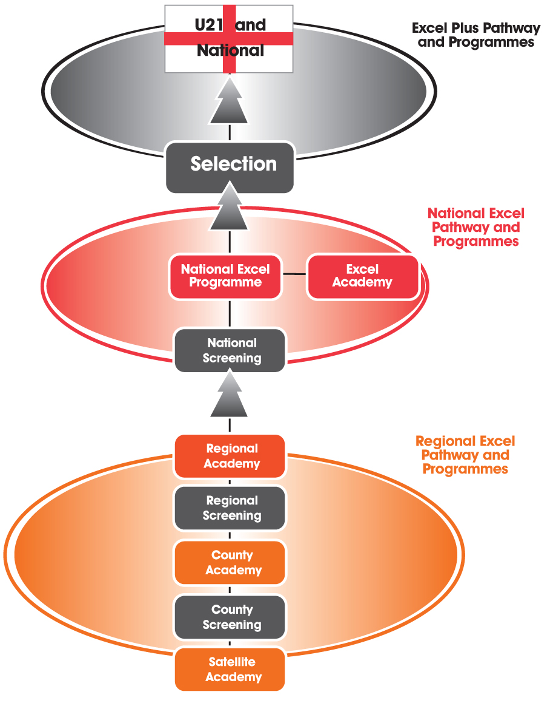
Honor de Winton - U19
Tamikah Campbell – U19
Beth Payne – U19
Jaydene Robinson – U17
Iman Thomas – U17
Brittany Coleman – U17

Northamptonshire/Club
Hannah Tunnicliffe – Northants JM’s
Tara Philby – Corby
Isabelle Balogun-Lynch – Futureprint
Sasha Atlas – Futureprint
Emily Burnham – Futureprint
Nottinghamshire/Club
Beth Shotton – Nottingham City
Emma Davies – Cliftonettes
Bethany Moore - Hucknall
Rebecca Nock - Cliftonettes
Derbyshire/Club
Cherese Naylor – Ripley
AASE Programme
Gaby Titley- Wilson
Megan Chapman
Sophie Matthews

NTL
Lynsey Cover (Nottinghamshire)
Iman Thomas (Nottinghamshire)
Gaby Titley-Wilson (Nottinghamshire)
Emily Watson (Lincolnshire)
Megan Chapman (Lincolnshire)
Tyler Bexton (Derbyshire)
Brittany Coleman Derbyshire)
Sophie Matthews (Derbyshire)
Jessica Smith (Derbyshire)
Isobel Beighton (Derbyshire)
Tamikah Campbell (Derbyshire)
Honor De winton (Northamptonshire)
Bliss Laurence (Northamptonshire)
Jaydene Robinson (Northamptonshire)
Beth & Claudia Payne (East)
Fran Duffy (Yorkshire & Humber)
Kathryn Binks/ Jemma King /Eleanor Durcan (Lboro Uni)

Leicestershire/Club
Beth Marron – Charnwood Sapphires
Adelaide Muskwe – Knighton
Charlotte Bateson – Knighton
Francesca Orton – Charnwood Sapphires
Tilly Rees – Cliftonetts
Elise Whearity – Charnwood Sapphires

Lincolnshire/Club
Hattie Haswell – Brigg & District
Pollyanna Seamer – Brigg & District
Olivia Sowerby – Brigg & District
Rosie Tate - Brigg & District
Becca Taylor - Brigg & District
Lilly Hughes – Sleaford Barge
Paige Carr – Lincoln City
Lynsey Cover – U19
Honor de Winton – U19
Tamikah Campbell – U19
Gaby Titley-Wilson – U19
Claudia Payne – U19
Beth Payne – U19
Isobel Beighton – U19
Iman Thomas – U17
Jaydene Robinson – U17
Brittany Coleman – U17
Beth Marron - U17
Pollyanna Seamer – U17

Recognition and Profile

I would first of all like to thank everybody from across the region who has either directly or indirectly, helped raise the profile of netball. As well as continuing to promote netball to one another and share our success stories, we have also made some great progress over the last 12 months in terms of raising our profile to the non-netballing communities.

Recognition and profile occurs through a ‘halo effect’- one great story often leads to another great story etc. We may not have heard about all of the consequences of the ‘netball recognition’ domino effects, nor even know where the original source of promotion came from. Therefore, I can only report things that have directly come across my path. Furthermore, there may be great examples of netball recognition and profile that have occurred at county level but I have tried to keep this report at regional level as best as I can.

Newspaper Submissions
This year R&P set up a “Newspapers Submission Page” on our Regional website (http://www.eastmidlandsnetball.co.uk/newspaper-submissions.html). This was to encourage teams who play in regional competitions and England Netball’s premier divisions to write and publish short match reports for their respective team. The reports were published on the East Midlands Netball website (http://www.eastmidlandsnetball.co.uk/reports.html). However, R&P also sent the reports off to the local newspapers of each respective team. It was felt that the weight of “East Midlands Netball” alongside the conversations R&P had had with various sports editors over the previous 12 months meant that we could promote netball in a way where the ‘whole‘ (i.e. East Midlands Netball) was considered greater than its constituent parts (i.e. every team) by the editors.

Typical ways in which the TSG engaged with sports editors included ringing and speaking to them about one netball story and then discussing the idea of match reports. The sports editors were really keen to receive match reports but needed them on a regular basis to be able to publish them. To further encourage editors to publish the reports, submitted match reports were accompanied by a header similar to the one below, which highlighted the fact that the level of netball being played was at regional level:

Dear Sir/Madam,

In line with East Midlands Netball and LOCOG’s legacy strategy to increase participation rates across the UK and to promote grassroots level sport in the local media, please see below for this week’s match report of Lincoln City 2 from the Lincolnshire area. This report is of the Lincoln City 2 vs. Nottingham Knights game from the East Midlands Netball Regional League, Division 2: (followed by the submitted report)

The first year of writing match reports in this way has been highly successful. We received almost 100 match reports over the season from 15 different teams, with Leicestershire’s Falcons Black (Premier League division 2), Grasshopper (Regional League division 2), Derbyshire’s Falcons Yellow (Regional League division 2) and Lincoln City 1 (Regional League division 1) and 2 (Regional League division 2) sending in the most reports, closely followed by a number of other teams.

Although a number of sports editors have their own way of dealing with match reports, the key issues were that reports were received very soon after a game (usually by Monday night if the game had been played on Sunday) so that they were turned around before the newspapers deadline (usually Tuesday lunchtime) and that submissions came in on a regular basis. By showing we could do this, the East Midlands Netball community made a number of significant recognition and profile breakthroughs:

- By sending regular netball match reports of teams that come from the Derby area or sending reports which discussed specific players who originate from the Derby area (and where the reports were tailored to promote this fact) since the beginning of the season, the Derby Telegraph sent the following email:

We now have a regular slot for netball (with the basketball and, occasionally volleyball!) on a Saturday.

Iceni and Pennine are regular features but we’d love more from other clubs, even if it’s just grassroots netball, or, even better, club successes, whether it be call-ups to talent squad or a special award for someone.

Please feel free to pass on my details – email is probably best – although remember that I’m only part-time so may not be able to respond straightaway…

Kerry Ganly
Sports Sub-Editor/Writer
Tel. 01332 291111 kganly@derbytelegraph.co.uk

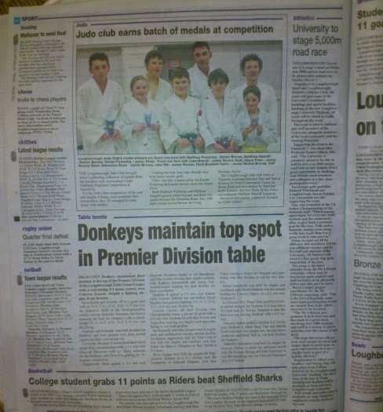
This email is really important because it shows that if newspapers receive match reports on a regular basis and in a timely fashion, space within the newspaper will be allocated to netball because the newspaper editor can be confident that they can fill the space with netball stories.

- On a number of occasions, netball managed to take over almost a whole sports page just on our sport. This was particularly true during the Loughborough Lightning season. Netball results unrelated to regional competitions were also found in the sports pages

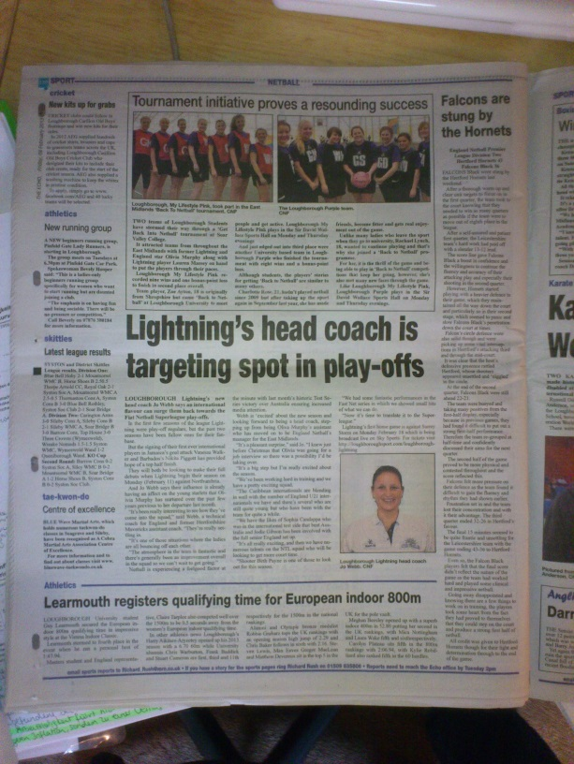
- Sports editors were now emailing R&P asking if a match report was going to be sent in to them because they were used to receiving reports. Below is an example of an email from Loughborough Echo asking about Falcons Black who hadn’t actually played that week

Hi,

Is there a Falcons Black report on its way this week?

Many thanks,

Richard Rush richard.rush@trinitymirror.com

Clearly, not all submitted reports will have made it into local newspapers but the more that are written and the more regularly they are written, the more likely this will be moving forward. Most importantly, they are easy to write. The general feedback from newspaper editors is that people should aim to write match reports of between 150-200 words (unless you have a specific agreement with a newspaper), involve a couple of paragraphs of action, a couple of paragraphs as an overview, any good performances that need to be highlighted (i.e. ‘Player of the Match’ and why), and finished off with the names of the players in the squad.

The TSG will continue to try and work with clubs to help them promote themselves by writing reports for the 2013/14 season.

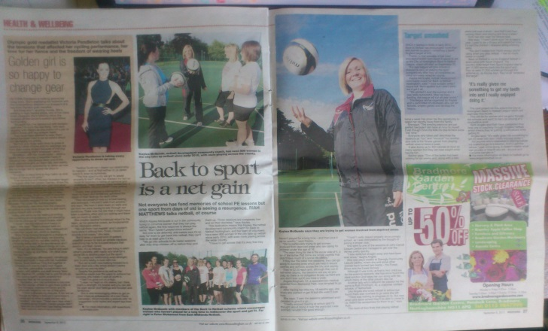
Other media successes
- Thanks to Dani Gatt (Nottingham Knights), we piggy-backed on a volunteering story for the Olympics to get netball volunteering mentioned on BBC Radio Nottingham

- We found ways of having netball brought into ‘health and wellbeing’ or ‘general interest’ sections of newspapers, partly by combining stories on grassroots with East Midlands/ Loughborough Lightning.
- We promoted a number of general netball success stories, even if the region’s netball community was indirectly part of the success. For example, we used England’s triumph over Australia to tell an “officials’ story”:

- The TSG helped out with this year’s Regional Back to Netball tournament by filming the day, posting footage posted online. The hope for the next 12 months is for more events like this to be attended and visual promotions produced.

- Perhaps our biggest success this year has been that BBC East Midlands has broadcast a feature on netball within the region. It is incredibly hard to engage television on general day-to-day netball stories but the progress that has been made in raising the profile and recognition of netball over the last two years meant that BBC East Midlands Today approached us for a story. It is hoped that we can continue to engage with regional television over the next season.
For the last two months or so, the TSG has been planning the Regional Celebration Event. We changed the format for 2013 based on the feedback we received last year. Again, feedback would be greatly appreciated so that we can continue to help you in any way we can.

Peter Dickenson
Recognition and Profile TSG Lead

East Midlands Youth Action Group

We’re pleased to give you an update on things we’ve been working on over the past 12 months, and to give you a small insight into what we want to achieve over the next 12 months. Due to the Regional Management Board’s governance review, we have been a little quiet in netball circles, but fear not, we are definitely still here and continuing to be the voice of the youth in the East Midlands.

Natalie led on the planning of the 2013 Regional Back to Netball Tournament working with a Committee to plan, organise and run the event. 11 teams attended and competition was high at Soar Valley College. Loughborough Lightning helped the ladies to warm up and also sold their stash. The day went really well and we’re looking forward to the 2014 event.

Sara led on the County Academy Tournaments at Loughborough University where each of the 8 county academies fought to be crowned 2013 winners. Despite the interference of snow, we successfully ran three competitions demonstrating the future talent of the region.

Pass on your Passion, England Netball’s reward scheme for volunteers aged 12-25 years has continued to grow and at the time of writing, the region boasted 182 registrations (up from 105 at this point last year- a whopping increase of 77!) This doesn’t include the many student volunteers who are registered under their home region but are dedicating their spare hours to netball development in the East Midlands.

We have created an East Midlands twitter account which currently has 360 followers and has engaged a wider netball audience of all age’s #teamYAG Facebook continues to thrive with 210 likes on our page. We are transferring the account from a profile to a page so if you do one thing today then make sure it’s to like us on facebook and follow us on twitter!

We have introduced a new voting system to rotate the Lead of the EMYAG and hope to recruit new members for the 2013/14 season shortly. Amy is our newest recruit and we are expecting to lose a few members who either return to their home region after studying here, or who are off to universities outside of the East Midlands.

On this note, we’d like to say a special goodbye to our Secretary Lauren Hindle who returns to Lancashire to continue studies to become a teacher. Lauren has been a huge asset to the EMYAG and we are all very grateful to her dedication and commitment. We’ll miss you Lauren! (Huggles!)

Also a special mention to Katie Griffin (#theOracle) who got married in September- we wish her and Ross all the best for the future. Our success continues with three members of the EMYAG being nominated for Goalden Globe awards which will be revealed later today, good luck to Lauren, Sofie and Sara.

Going forward, we are striving to improve our communications with all and will increase our interaction through twitter and facebook #getinvolved. We hope to further increase the number of Pass on your Passion registrations and also look to support more young people aspiring to coach; umpire or volunteer in any other way throughout our clubs; schools; academies and performance pathways.

Get in touch with us through: Email: eastmidlands@englandnetball.co.uk (Messages will be forwarded to the Lead of the EMYAG); twitter: EastMidlandsNet Facebook: East Midlands Netball
EMYAG

