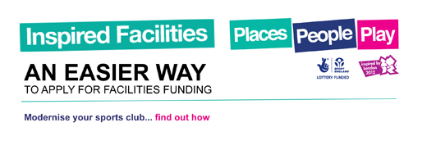
New Courts officially opened in Bassingham
Saturday 25th May saw the official opening of the newly refurbished Bassingham Netball courts as part of the villages’ Community Sports Day. The court refurbishment has been funded in partnership with Sport England Inspired Facility Funding of £40,000 and added investment from Bassingham Parish Council.
The day was opened by Chairman of the Parish and Bassingham sports star Jack Harvey. Jack is one of Britain's brightest motor racing prospects. Aged 20 he has already won ten driver Championships, including the 2012 British F3 Championship, and is touted by a number of industry experts as one to watch for the future.
Bassingham Belles Back to Netball Club hosted a friendly game with members from the Grantham and Collingham schemes. The ladies played a pick and mix game, swapping bibs and teams to really bring together the whole ethos of B2N of Fun Friendly Fitness.
Bassingham Belles are one of the longest running schemes in Lincolnshire. They put their success down to the friendships which have formed both on and away from the courts. Not content in coming third in the inaugural Lincolnshire B2N Grand Prix, they have also entered other events as the Belles including the Zombie Run last month at Swinderby and the Bassingham ‘It’s a knockout’ competition where they took great pride in beating the cricket team at Tug of War.
Bassingham Belles train on Monday evenings from 7- 9pm at the Hammond Hall netball courts, Lincoln Rd, Bassingham. Cost £3.00 per session.
For more information contact Louise Key Lincolnshire Netball Development Officer email: louise.key@englandnetball.co.uk Tel: 07545 924994

