
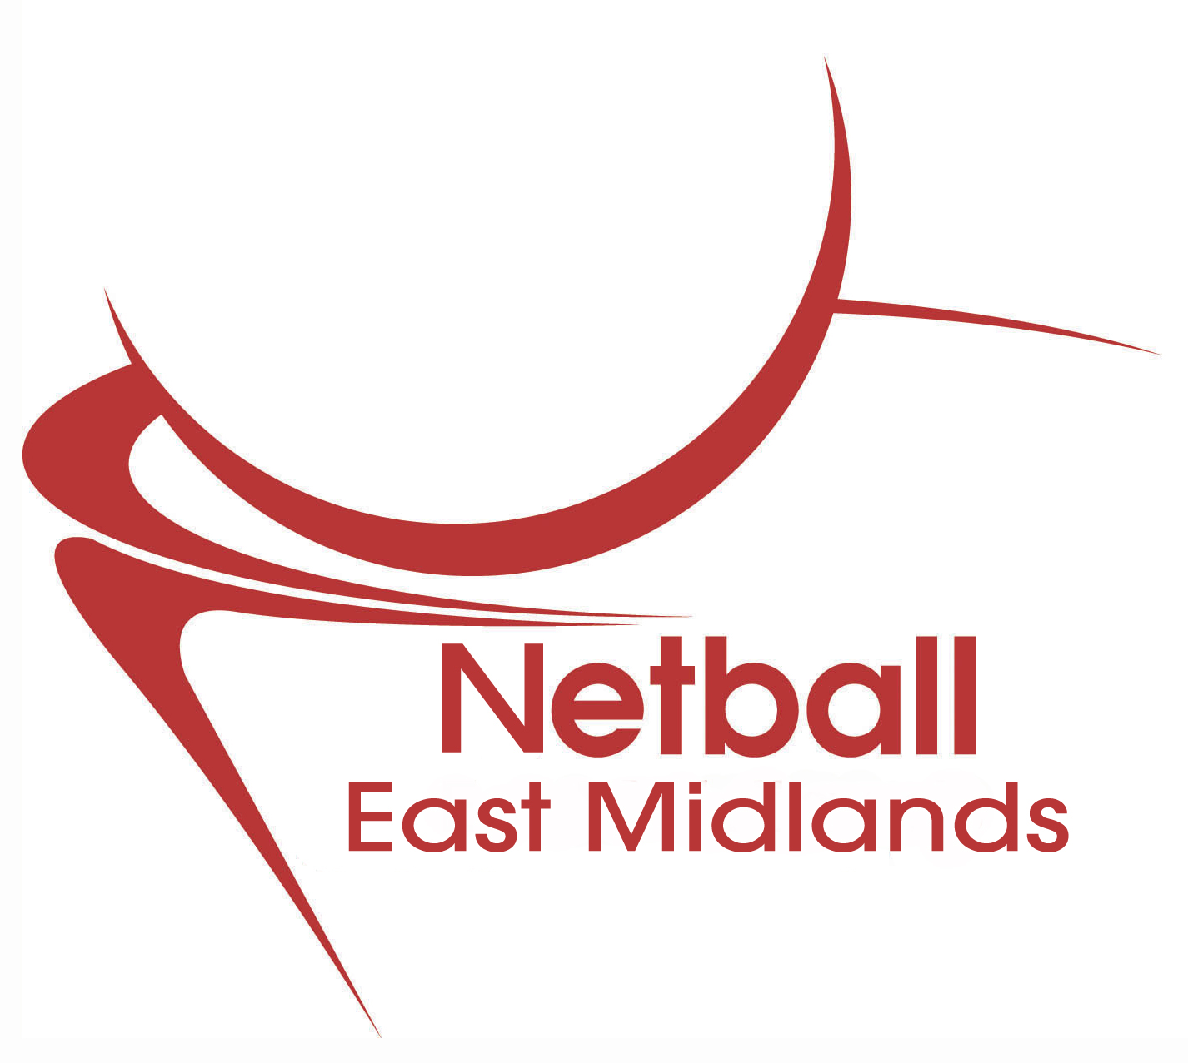

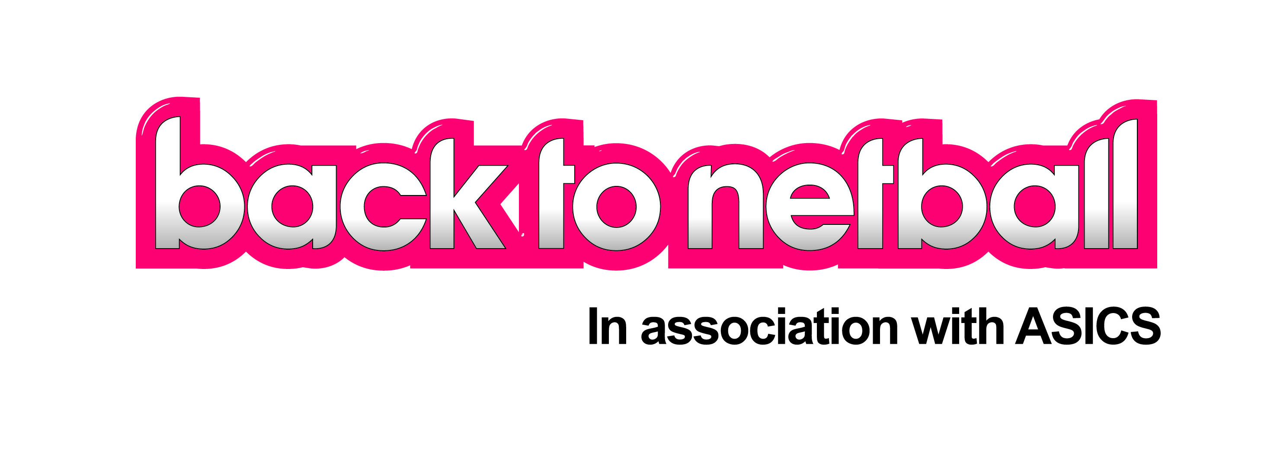
Lincolnshire

Grand Prix

The Grand Prix will be a series of tournaments as part of the Lincolnshire County League 2015/16

Your team can enter as many or as few of the tournaments as you wish, and there will be winners at each. The points accrued at each tournament will accumulate over the series to give an overall winner for the 2015/16 season.

The Tournaments will be held on

18th October 2015 Grantham
15th November 2015 Lincoln
21st February 2016 Lincoln
13th March 2016 Grantham/Bassingham
10th April 2016 Grantham

Grantham – Meres Leisure Centre Trent Road Grantham
Lincoln -Lincoln College Monks Rd Lincoln LN2 5HQ
10pm – 4pm
Cost £35.00 per Tournament

The tournaments will be open to teams across the East Midlands, but we will need verification from your NDO that you are a team developed from the B2N programme.

Please add these dates to your diaries. Closing dates for each tournament will be 2 weeks before.


Team Registration form

Name of Back to Netball Team _____________________________

Name of Coach _____________________________

Umpire ( if possible) _____________________________
Contact Number _____________________________

Email Address _____________________________

Postal Address (including postcode) _____________________________

Group formed (date) _____________________________

Netball Development Officer _____________________________

COACH: Are you attending the B2N Tournament with your players? Yes No

Names of players:
1 _______________________ 7 _______________________
2 _______________________ 8 _______________________
3 _______________________ 9 _______________________
4 _______________________ 10 ______________________
5 _______________________ 11 ______________________
6 _______________________ 12 ______________________

All players must be aged 16 and above.

Please return the above information 2 weeks prior to the tournament you are entering with your £30 entry fee made payable to Lincolnshire County Netball Association to:

Louise Key
Lincolnshire Netball Development Officer

Lincolnshire Sports Partnership
Eco 1 Highcliff Farm
Ingham
Lincs LN1 2WE

E louise.key@englandnetball.co.uk
M 07545 924994


