Brigg Netball Club Tournament Entry Form:
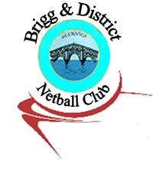
Hi 5(U9 & U11), U12, U14 & U16 – Saturday 29th July

Times TBC once entries are all in

Venue : Frederick Gough School , Grange Lane South, Scunthorpe, DN16 3NG

Team Name: ______________________________Age group_________
Team Name: ______________________________Age group_________ Team Name: ______________________________Age group_________
Team Name: ______________________________Age group_________
Team Name: ______________________________Age group_________
Team Name: ______________________________Age group_________
Team Name: ______________________________Age group_________

Contact details for fixtures etc. to be sent to:
Email address: __________________________________ (please print clearly). Emergency Mobile no._________________________

(Maximum 2 teams per club per age group)

Cost £35 per Hi 5 team – each player receives medal
All other age groups £25 per team (medals for 1st, 2nd & 3rd place)

Deposit – returnable on completion of all fixtures on the day of £20 per team

Please note there will be various stalls on the day including a BBQ and hot / cold drinks.

Please send completed from and cheques payable to Brigg Netball Club to Vanessa McErlain, 51 Swift Drive, Scawby Brook , DN20 9FL no later than 16/7/16.
Failure to attend (with or without notice after 16/7/16) will result in entry fees and deposit being cashed.

