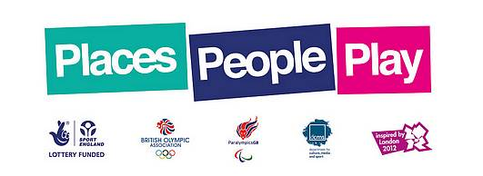

Bassingham Back to Netball helps secure £40,000 Grant
Part of Places, People, Play – Sport England’s programme to deliver a London 2012 legacy of increased mass participation in sport – the funding has been awarded through the Inspired Facilities Fund which is investing £50 million of National Lottery funding in 1,000 community sports projects between 2011 and 2014.
The title of the bid ‘Bring Sport Back to Bassingham’ was submitted by Bassingham Parish Council with the support of England Netball.
This project will resurface two existing netball/tennis courts including installing new fencing, goal posts and nets. This will enable the continuation of the Bassingham Back to Netball training, and the new courts will enable matches and tournaments at the site, the development of a junior netball team, as well as multi use for other sports.
Louise Key, Lincolnshire Netball Development Officer said “ To see the ladies so excited about their new courts shows how much ownership they have taken of the B2N scheme, supporting the ethos of My Game”
Inspired Facilities is focused on making it easier for local community and volunteer groups to improve and refurbish sports clubs or transform non-sporting venues into modern grassroots sport facilities.
Janet Inman, Chief Executive Officer at Lincolnshire Sports Partnership, said: “We are delighted that venues in Lincolnshire have received funding to improve their sports facilities and enable more people across the county to take part in sport. Lincolnshire Sports Partnership are encouraging more people, to be more active, more often, and the Inspired Facilities fund is helping us to achieve this goal.”
The Bassingham scheme runs on Monday evenings from 7pm till 8.30 and costs £3.00 per session. (The scheme will be on a summer break in August, recommencing 3rd September)
For more information on Back to Netball in Lincolnshire
contact Louise Key: louise.key@englandnetball.co.uk or visit www.englandnetball.co.uk.

