EAST MIDLANDS NETBALL DECEMBER 2015 E-BLAST

Please share the East Midlands Netball e-blast with your club members & contacts so as many people as possible know what is happening within the region! If you don’t receive this direct from us and want to be added to our mailing list, email eastmidlands@englandnetball.co.uk

Previous versions are available on our website
Seasons Greetings!

East Midlands Netball staff and the Regional Management Board would like to wish all our members and partners a very Merry Christmas and a Happy New Year- see you in 2016!
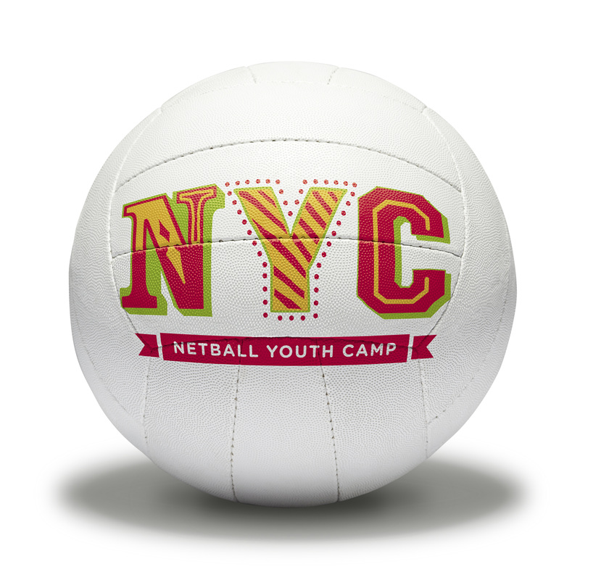 | Netball Youth Camp  A Netball Youth Camp is taking place in February half term and you can book your child(ren) on to join in now! The camp is open to both 9-11 years and 12-16 years and is set to be a fantastic day of nothing but netball!  Date: 17th February 2016 9am-5pm  Venue: Soar Valley College, Gleneagles Avenue, Leicester, LE4 7GY  Price: £40 members (just £5p/h!) or £50 non members. 10% sibling discount  To book: visit our netball events website
Volunteers Required

You still have the opportunity to volunteer with England Netball at Super Saturday- the opening day of the 2016 Vitality Netball Superleague season.

Chose which shift you wish to work – meaning you get to watch your teams match as a spectator as well as being involved as a vital member of the delivery team. You will also receive a crew t-Shirt and refreshments during the day.

Roles include ball patrol; merchandise and event assistants; mascots; programme sellers and more! For information see the England Netball website.
Make the Game Live- Coaching On the Road

England Netball are taking the Make the Game Live Conference on the Road.

Date: Monday 22nd February 2016
Time: 6:30-9:30pm
Venue: Welbeck College, Loughborough

The Roadshow is running to deliver messages from the national conference to those who were unable to attend. Understand how the game is changing and what that means for your coaching; get updates on key messages and embed game based practice into your coaching and design practices that maximise player decision making! To book onto the East Midlands roadshow, visit the regional website to download a booking form.
Coaching Courses

Apologies for not releasing all course details as planned last month. Here we round up details of all coaching courses now available to book on in the East Midlands. Download a booking form via the England Netball website

Level 1
Costs: £150 affiliated members; £180 non affiliated members

Date: 24th April and 22nd May 2016
Venue: University of Lincoln Sports Centre, Ropewalk, Lincoln

Please note we aim to release one further Level 1 course for this period soon!

Level 2
Costs: £360 affiliated members; £395 non affiliated members

Date: 16th & 17th April; 14th; 15th May and 11th June 2016
Venue: Moulton College Northampton

Date: 24th; 25th September; 15th; 16th October and 12th November
Venue: Derby University
East Midlands Funding

East Midlands Netball wish to support affiliated members through subsidies and mentoring opportunities to help develop coaches; tutors; umpires; assessors; volunteers and players across the region.

To apply for a grant from the region, visit our website to download an application form. Forms must be sent prior to attendance and can not be paid retrospectively.
East Midlands 12-25 Bursary

A bursary is available to help the development of netball throughout the East Midlands to support and increase opportunities for netballers aged 12-25.

If you have a project which targets this age group and is looking to create a minimum of 15 new netballers, check out the bursary guidelines on our website.
Loughborough Lightning

Loughborough Lightning have put together a programme of coach workshops and bookings are being taken now. Topics include centre pass attack and defence; soft skills; strength and condition and are delivered by expert coaches.

To book your place on a workshop; purchase tickets to matches or just to keep up with all Lightning news, visit their website
Regional Fast Net Tournament 2016

We will be hosting a Fast Net tournament on Sunday 22nd May 2016 to raise funds for Cancer Research UK. A maximum of 20 teams can enter on a first come first served basis at a cost of £30 per team. Players must be affiliated to England Netball, but not necessarily to the team they are representing.

To enter, complete a booking form (available on our website) and return to the office with payment.
Netball at Willows Sports Centre, Derby

Willows Sports Centre are running a new 7 a side league will take place on Wednesday evenings 6-8pm from January 2016 (umpires will be provided). There are now very limited places available so for more information, don’t miss out and call Chantelle today 01332 204004

The team would like to wish all netballers in the East Midlands a very Merry Christmas and a Happy New Year and look forward to welcoming you to the Centre in 2016!
Goalden Globes & Celebration Event 2016

Don’t forget to save the date for our 2016 Goalden Globes and Celebration Event!

Saturday 25th June 2016

A three course meal will be served at the Radisson Blu Hotel, East Midlands Airport, followed by dancing into the early hours. Times and costs as well as the nomination process for 2016 will be communicated shortly. Please get your players; coaches; umpires; supporters and the whole netball family to put it in their diaries!
Regional Newsletter

We are always on the lookout for good news stories throughout the East Midlands to share in our regional newsletter. If you would like to feature in our next issue, please send us your story! A useful template is available on our website.

The October edition can now be found on our website and is also attached to this email. The cut-off date for the next newsletter is Friday 8th January 2016.
Staff Contacts

East Midlands Regional Manager- Steven Benson
steven.benson@englandnetball.co.uk 07970 059904

East Midlands Regional Coordinator- Katie Griffin
eastmidlands@englandnetball.co.uk 01509 226753

Derbyshire/Nottinghamshire Netball Development Officer – Julian Taylor
julian.taylor@englandnetball.co.uk 07545 924993

Nottinghamshire/Derbyshire Netball Development Community Coach- Ruth Pickthorn ruth.pickthorn@englandnetball.co.uk 07872 407215
Lincolnshire Netball Development Officer – Louise Key
louise.key@englandnetball.co.uk 07545 924994
Leicestershire Netball Development Officer – Val Kindred
v.kindred@lrsport.org 07540 126816
Northamptonshire Netball Development Officer – Kelly Walker
kelly.walker@englandnetball.co.uk 07545 924954

East Midland Performance Pathway Coach - Sam Brightman
samantha.brightman@englandnetball.co.uk 07525 702639
To keep up to date with everything that is going on in the region, don’t forget to check out our website and follow us on social media-
www.eastmidlandsnetball.co.uk

www.facebook.com/EastMidlandsNetball
@EMNetball

