East Midlands Netball

Technical Support Group Reports

2011-2012

Competition

Report loosely covers the period 1st September 2010– 31st May 2012

Members of the Group
Lead Carol Spencer
County Reps Derbys- Caroline Richards
Leics- Kathy Stripp
Lynn Moore (Regional League Co-ordinator)
Lincs- Paula Hill (U16 League Co-ordinator )
Nhants- Yvonne Blunt
Notts- Liz Lorrimer
Umpiring Heather Gleadall
Regional Chair Sue Collin

Regional Manager Anne Henderson

Structure of the Group
The Competition TSG is made up of ten people and consists of the TSG Lead, a representative from each county, an Umpire Representative and the Regional League Secretary. The Regional Chair and Regional Manager are also invited to attend the bi-monthly meetings. We meet to plan all aspects of forthcoming events including age restrictions, establish procedures and protocols, eligibility, rules and regulations, allocation of events etc.

Appraisals
We appraise every event and implement changes to procedures and Rules and Regulations to improve the quality of netball provision at regional level. When you are given an appraisal form to fill in, please complete and return. It is the best way we have of improving the service we give and making sure we are meeting your needs.

We discuss the feedback we receive from members and try to implement changes to give the clubs what they want. Our aim is to provide a high level of competition, at a reasonable price, at quality venues and ultimately give teams a positive experience - win or lose.

Opportunities

There are regional competition opportunities available at every level, some open entry and some where clubs need to qualify through a county competition. We have introduced an annual Open Fast Net Tournament in the hope of encouraging new teams to experience regional netball.

Once again, there was a disappointing number of entries for the junior competitions - U12's and Clubs High 5's. The Schools High 5's did not happen in 2012 because counties were committed to the Schools Games. Hopefully this event will happen again next year. Even the 2012 Clubs U14 Tournament was undersubscribed.

These youngsters are the future of Netball - let's not lose them to other sports. PLEASE consider starting a junior section at your club, don't assume they will come ready trained in ten years time!

Questions I asked last year:-
Is the information getting through to the right people?
Are the competitions at the wrong time of year, wrong day of the week, wrong time?
Are teams not interested in playing at a higher level?
WE NEED TO KNOW: carolspencer2@btinternet.com
Competitions planned for 2012-13 season
Regional Open League Sept 2012 – April 2013 County Qualifier
Clubs U16 Competition 10th, 24th March, 14th April County Qualifier
Schools U14, U16, U19 26th January 2013 County Qualifier
Clubs U14s 7th April 2013 County Qualifier
Clubs High 5 12th May 2013 Open Entry
Clubs U12s 12th May 2013 Open Entry
Open Fast Net Tournament 9th June 2013 Open Entry

Schools High 5 23rd June 2013 County Qualifier
Qualifying Tournament 7th July 2013 County Qualifier

Check with your County Secretary, the East Midlands website or Carol Spencer carolspencer2@btinternet.com for details of entry into any of the above competitions.

The Regional League Qualifying Tournament 2013 is for entry into the Regional League in September 2014. This is a vital part of maintaining the Regional League and offers the opportunity to two clubs from each county to vie for places in the league. If you want to see what the standard is like, come along to Loughborough University on any of the following Sundays 10am - 3.30pm

Regional League dates 2012-2013
July 7th (SDW - Qualifying Tournament)
September 16th (NC) , 23rd (SDW), 30th (NC)
October 7th (NC), 21st (SDW), 28th (SDW)
November 4th (SDW), 18th (SDW)
December 2nd (SDW)
January 13th (NC), 20th (NC)
February 3rd (NC), 17th (NC)
March 17th (SDW)
April 14th (SDW - Play offs to decide promotion/relegation between Division 1 and Division 2)
(NC = Netball Centre; SDW = Sir David Wallace Sports Hall - both at Loughborough University)

U16 League & Play offs
The League was again a popular event providing the opportunity for two teams from each county to take part. The League was followed by the top two teams from each section competing in the play offs at Loughborough University and produced some very competitive netball which was well supported by friends and parents. The winners and runners up from the play offs went on to represent the region at the National U16s Final.

The format of the U16 Competition will change next year due to availability of dates and demand on players' time during exam time. Tthe competition will take place on three weekends - 10th, 24th March and 14th April. Ten teams (two from each county) will play each other once indoors at Loughborough University in March and the top four teams will meet again in the play offs on 14th April to decide our two qualifiers for the National Finals.

Finance
Our tournaments continue to rotate around the region, giving each county the opportunity to stage the various events which gives clubs the occasional chance of a ‘home’ venue. However, the cost of venue hire, first aid, umpire travel expenses and local workforce varies tremendously across the region and makes the setting of entry fees very difficult. It is our aim to produce neither a profit nor a loss. A profit from one event goes to offset the loss of another either within the same season or from year to year.

Primary Carer Armbands
Primary Carer Armbands were introduced to some tournaments and the Regional League to assist umpires in knowing who is allowed on court in the event of an injury. These have been very effective, but do disappear. AMNESTY - please return to the Netball Office!

It is disappointing that teams from the region do not make an impact at national level, but initiatives being introduced by the Regional Management Board hope to raise the performance profile of our regional teams.

Carol Spencer
Competition TSG Lead
Competition Results 2011-2012

Fast Net (Sept 2011) 1st TFC
2nd Pennine A
3rd Iceni
4th Pennine B
5th Lincoln City

National Tournament
(Top team from 7 regions)
TFC played in National event - position not known
__________________________________________________________________________________

U14 Schools Tournament 1st Nottingham Girls High School
2nd Trent College
3rd Loughborough High School
4th Oundle School
5th Caister
6th West Bridgford
7th Northampton High School 8th Chapel en le Frith
9th = Oakham
9th = Priory Academy

National Schools U14 Finals
(Top two qualifiers from each Region)
NGHS finished 17th =, Trent college finished 15th =

U16 Schools Tournament 1st Nottingham High School
2nd Stamford
3rd Oundle
4th Loughborough High School
5th Trent College
6th Northants High School
7th Chapel en le Frith
8th West Bridgford
9th = Leicester Grammar School
9th = Vale Academy

National Schools U16 Finals
(Top two qualifiers from each Region)
NGHS finished 13th =, Stamford finished 13th =

U19 Schools Tournament 1st Oundle
2nd Bilborough
3rd Priory Academy
4th Wellingborough
5th Nottingham Girls High School
6th Trent College
7th Oakham
8th Loughborough High School
9th = Deeping
9th = Repton

National Schools U19 Finals
(Top two qualifiers from each Region)
Oundle finished 15th = Bilborough finished 9th =

U14 Clubs Tournament 1st Cliftonettes Black
2nd Charnwood
3rd` Ripley
4th Brigg and District
5th Horncastle
6th Cliftonettes Glod
7th Rutland Rockets

National Finals
(Top 2 qualifiers from each region)
Charnwood finished 14th / 18, Cliftonettes finished 17th /18
__________________________________________________________________________________
U16 League Section A Section B
1st Charnwood Nottingham City
2nd Brigg & District Long Eaton
3rd Northants JMs Futureprint
4th Cliftonettes Sleaford Barge
5th Pennine Lincoln City
(Top 2 from each section go forward to the Regional Play offs)
__________________________________________________________________________________

U16 Regional Play offs 1st Nottingham City Allstars
2nd Brigg
3rd Charnwood
4th Long Eaton

National Finals
(Top 2 teams from each region)
Nottingham City finished 17th / 18, Brigg finished 16th / 18
__________________________________________________________________________________

Regional League 2011-12 Div 1 Div 2

1st TFC Northants JMs 2nd Leapoole Pennine
3rd Nottingham City Aces Nottingham Knights
4th Lincoln City 1 Iceni
5th Hinckley Hurricanes Charnwood
6th Bluetits Sleaford Barge
7th Phoenix Lincoln City 2
8th Falcons Notts City Comets
JMs – automatic promotion Div 1
Falcons – automatic relegation to Div 2
__________________________________________________________________________________

Regional League Play offs 6th & 7th from Div 1 and 2nd & 3rd from Div 2 contested
the Regional Playoffs

1st Bluetits placed in Div 1
2nd Pennine placed in Div 1
3rd Nottingham Knights placed in Div 2
4th Phoenix placed in Div 2

National Play offs (to find 3 teams to join Premier League Div 3) (Winner from each region)
TFC finished = 2nd in section and lost in the play offs

Qualifying Tournament Open to the top 2 teams from each county
(to find the 2 teams to join and the teams finishing 7th and 8th in R/L Division 2
Div 2 of the Regional League 1st Lincoln City 2
2012-2013) 2nd Brigg & District
3rd Grasshoppers
4th TFC Too
5th Nottingham City Comets
6th Cliftonettes
7th Sleaford Barge

Lincoln City 2 and Brigg will join Division next season _________________________________________________________________________________
Clubs High 5’s 1st Corby
2nd Futureprint
3rd Allestree
4th Cliftonettes
__________________________________________________________________________________
U12’s Tournament 1st Futureprint
2nd Allestree
3rd Cliftonettes Black
4th Fenland
5th Corby
6th Cliftonettes Blue
7th Boston
8th Clifton Gold
9th Nottingham City 1
10th Nottingham City 2
__________________________________________________________________________________

Fastnet (June 2012) 1st TFC 2nd Hinckley Hurricanes
3rd = Nottingham Aces 3rd = Pennine
5th = Knighton 5th = TFC 2
7th= Lincoln City 7th = Sleaford Barge
9th = Notts Comets 9th = Notts Diamonds
Education and Training

2011/2012 has been another busy but successful year in the East Midlands.

There have been a number of level 1 and level 2 coaching courses organised throughout the region again this year but unfortunately, a number of the level 1 courses had to be cancelled due to lack of candidates. We try to hold the Level 1’s across the whole region, hopefully making them accessible for all. The Level 2 courses are held centrally. Grants have been issued to support Level 2 and level 3 courses and it is hoped individual counties will support those on a level 1 course. There have also been a number of skills workshops running throughout the region.

We held a very successful B Award Umpiring course in September 2011 with 15 candidates taking part. We extended our Mentoring programme at the County Tournaments held at Loughborough College during January and February this year and have provided Mentors at as many events during the season as possible. Many thanks must go to all those Mentors who have supported the programme, providing expert help to our up and coming umpires. We have found it difficult to get enough testers out to assess umpires prior to applying for their tests but with two new testers this year, Anne Henderson and Donna Beckett, things are improving. Congratulations go to both Anne and Donna. We also now have a waiting list of people wishing to become B Award testers. We have three new B Award umpires this year, Lucy Siena from Derbyshire last June; Dani Gatt from Nottinghamshire and Sara Bostock from Leicestershire both in March this year. We also have a number having already passed their assessment who are just awaiting their tests.

The region continues to support both Umpires and Coaches with the grant system, the details of which are on the regional website. If you are unsure whether you qualify for a grant, please contact us and we will be able to advise you.

We are all looking forward to building on this positive work throughout 2012/13.

Jo Stephenson
Education and Training TSG Lead

Excel Talent

This has been an eventful and successful year for our TSG group. For the purpose of simplicity it is easier if each level of our Excel is referred to in order.

NTL
Screening took place in October with all our regional athletes attending alongside some University athletes and some players from outside of our region who wanted to try and become part of our regions NTL squad.

The successful athletes were:
Leicestershire - Bethany Smith
Nottinghamshire – Lynsey Cover; Iman Thomas
Derbyshire – Elisha Cooper; Issy Beighton; Jess Smith; Harriet Wingfield; Tyler Bexton
Lincolnshire – Rebecca Heald; Emily Coulter; Emily Watson; Shannon Boothright
Northants – Honor de Winton; Bliss Lawrence
University – Anna Bird; Domique McKee; Charlotte Huckle
East Region – Beth Payne; Claudia Payne; Simeone Compton
Staffordshire – Ashley Dodds

New coaching team- Rosie Port; Val Kindred; Donna Swann; Kaylea McQuade
The results fail to reflect how successful this team were as they were newly put together in October as a team and they progressed rapidly, playing well established NTL squads and only losing by narrow margins. By the final weekend they were the team being talked about as they narrowly lost to Northern Thunder (the winners of the whole competition). What is to our regions credit is how many of our young athletes gained a place over older University players initially and grew throughout the season into mature and confident performers.

Regional Excel
Our Regional screening took place in October as well with an excellent compliment of athletes representing the Counties

The players were:
Leicestershire – Beth Marron; Adelaide Muskwe; Ashleigh Plumtre
Nottinghamshire – Gaby Titley-Wilson; Beth Shotton; Laura Borrie; Thea Thompson; Emma Davies; Katie Cresswell
Derbyshire – Cherese Naylor; Sophie Mathews; Tamikah Campbell; Britt any Coleman; Isabella Sturgess; Katie Ward; Ella Ritchie
Lincolnshire – Megan Chapman
Northants - Jaydene Robinson; Annie Bolle –Jones; Dannielle Murphy; Hannah Tunnicliffe; Ella Sturley

The Regional sessions have gone well with several coaches coming in to help. Athletes have been working on increasing their number of training hours as they should be training approximately 15 hours a week, if they are to develop further. They have gained immensely from the competitions they have played in front of an audience prior to Loughborough Lightning’s home fixtures and also the invited competitions we have provided during training.

National Screening
U19 – Jess Smith; Lynsey Cover; Emily Watson; Annie Bolle Jones; Claudia Payne; Beth Payne; Honor de Winton

U17 – Iman Thomas; Jaydene Robinson; Gaby Titley-Wilson; Tamikah Campbell; Brittany Coleman

Honor de Winton remains in the National programme indeed being fast tracked through to the U21 National Squad and Jaydene Robinson has been accepted into the U 17 training squad.The other players performed well but need to do some more work before being sent to National screening again.

County Excel
The lead coaches have continued to do an admiral job bringing the players on and gave up yet more of their time and skills bringing them to competitions prior to Loughborough Lightning fixtures. A big thank you to Jo Stephenson for organising the umpires for all these competitions and to Donna Beckett for the work she has done at all levels to make sure things happen.

Where to next?
If we are to succeed in driving our talented athletes forward we have to ensure we provide adequate quality competition and intense and regular training opportunities for them. They WILL NOT progress if they continue to train at their current level. The TSG group has recognised that we need to ensure our top layer of athletes are being stretched and some of the County Head Scouts have tried to set up some EXCEL PLUS sessions for very small groups of athletes to work with quality coaches outside of their club/regional/NTL training. Bev Burnham in Northants has been extremely successful with this working with Honor de Winton and Jaydene Robinson who have both been taken at National screening.

Our challenge is to increase the number of quality contact hours we have with our Excel athletes particularly at the top end but all the way down the pathway so that they hit the ground running when they reach the regional programme instead of taking a season to adjust.Obviously this will impact on our coaches and volunteers who already give up so much of their time so we will be trying to be both inventive and resourceful in our plans moving forward.

Finally we would just like to say a BIG THANK YOU to you all for your help and support during 2011-12 season.

Val Kindred Rosie Port
Excel TSG Lead Regional Excel Coach

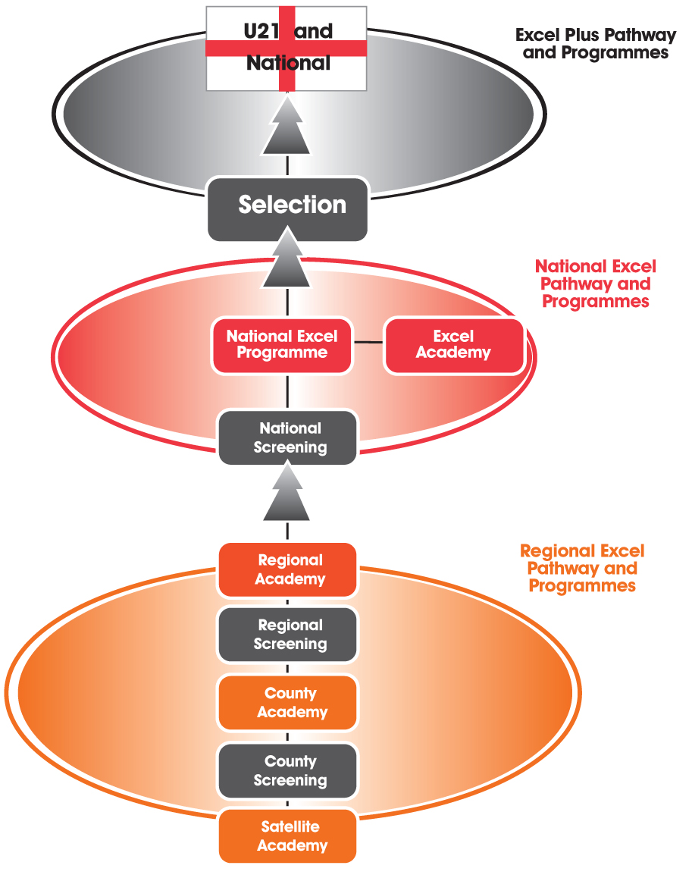
Honor de Winton - U19
Jaydene Robinson – U17

Lynsey Cover – U19
Jessica Smith - U19
Emily Watson – U19
Honnor de Winton – U19
Annie Bolle Jones - U19
Claudia Payne – U19
Beth Payne – U19
Iman Thomas – U17
Jaydene Robinson – U17
Tamikah Campbell – U17
Brittany Coleman – U17
Gaby Titley-Wilson – U17

Lincolnshire/Club
Megan Chapman – Brigg & District

Nottinghamshire/Club
Gaby Titley-Wilson – Nottingham City
Beth Shotton – Nottingham City
Laura Borrie – Cliftonettes
Thea Thompson – Nottingham City
Katie Cresswell – Nottingham City
Emma Davies – Cliftonettes

Northants/Club
Jaydene Robinson – Northants JMs
Annie Bolle Jones – Oundle
Dannielle Murphy – Kettering Cougars
Hannah Tunnicliffe – Northants JMs
Ella Sturley – Northants JMs

NTL
Lynsey Cover - (Nottinghamshire)
Iman Thomas – (Nottinghamshire)
Emily Watson – (Lincolnshire)
Emily Coulter – (Lincolnshire)
Rebecca Heald – (Lincolnshire)
Shannon Boothright – (Lincolnshire)
Tyler Bexton – (Derbyshire)
Harriet Wingfield – Derbyshire)
Elisha Cooper – (Derbyshire)
Jessica Smith - (Derbyshire)
Isobel Beighton - (Derbyshire)
Harriet Wingfield – (Derbyshire)
Beth Smith – (Leicestershire)
Honnor De winton – (Northamptonshire)
Bliss Lawrence – (Northamptonshire)
Beth & Claudia Payne, Simone Compton - (EAST)
Anna Bird, Domique McKee, Charlotte Huckle – (Lboro Uni)

Derbyshire/Club
Cherese Naylor – Ripley
Isabella – Sturgess – Pennine
Sophie Mathews – Ripley
Tamikah Campbell – Long Eaton
Brittany Coleman – Long Eaton
Katie Ward - Ashbourne
Ella Ritchie – Wirksworth

Leicestershire/Club
Beth Marron – Charnwood Sapphires
Adelaide Muskwe – Knighton
Ashleigh Plumtre – Melton

Recognition and Profile

As Lead of the Recognition and Profile Technical Support Group, I would like to thank all those people who have directly and indirectly helped the group in one capacity or another. This group very much depends on the whole of the netballing community to help achieve its main goals.

The main purpose of the group is to recognise and publicise achievements and successes of netball members and to raise the profile of netball amongst the non-netball community. This includes from a sporting perspective as well as a non-sporting perspective.

Having been part of the original set up, I became the new Lead in September last year. The remaining part of 2011 was spent recruiting for the group and defining and signing off on the precise roles and responsibilities the group will have.

Four members were recruited from Loughborough University – two in their final year (and will be leaving soon) and two in their penultimate year. Due to the nature of this embryonic group, it was difficult to recruit members from outside the Loughborough area but the hope is that this will be the starting place to grow the group organically so that members of the netball community from across the region will become members of group in the near future. Group members are always being sought so please do get in touch if you know of somebody.

For the group’s goals to be achieved, an outlet is needed, which is external to the netballing community. This outlet is currently the media which traditionally has not focussed on netball. Therefore the group’s first task was to speak to the media (local newspapers, radio and TV) to try and find out if and how netball stories were used. The positive news was that in most cases, the local newspapers had said that they would print more netball stories or put some on them on their websites but they needed the stories to do this. A lot of the newspapers also said that they had not received a netball story in time for printing and would have liked a photograph to complement if possible. On top of this, newspapers now employ relatively few members of staff and therefore a reasonably well-written story/report would make their job easier.

However, the biggest challenge the group has comes from the fact that the non-netballing community has little appreciation on the standard of playing ability a team in each league has (or knows little about netball in general). Yet it is quite clear that the netball community understands this. Therefore a hierarchical ‘ideal media concentration’ pyramid was produced (see figure 1) to help drive one of the group’s long-term goals of raising the profile of netball amongst the non-netball community. This diagram can be used as an aid by anyone within the netball community.

Clearly, not all stories will make it into a newspaper but the more that are written, the more likely this will be. The group is also exploring other channels (such as a designated area on the East Midlands Netball website) where specific stories, told by its members, can be posted as an alternative platform. More news on this will be coming out over the coming months.

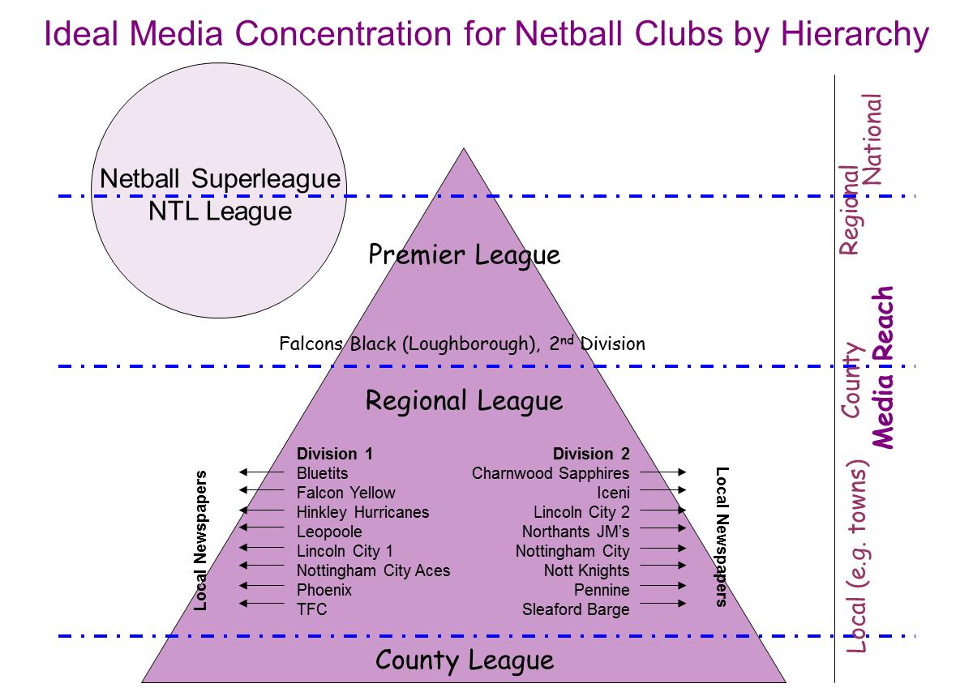
Strategically, the best way for the media to become engaged in netball at all levels is for us to first leverage our biggest netballing brand in the region – Loughborough Lightning (please see figure 2). Although not officially part of East Midlands Netball or one of the five counties, all parties are inextricably linked, especially if all aspects of netball (development, education, media etc.) are to succeed to the level we would all like. Consequently, the collaboration between Loughborough Lightning and East Midlands Netball has been on-going over the course of the last 12 months and to the benefit of all sides. For example, the Recognition and Profile Group have recorded and edited small videos of Lightning games for Lightning TV (You Tube) and had BBC Radio Leicester announce the teams result on its morning sports report. This has helped netball be perceived as an elite sport within the region because it is mentioned alongside the male-dominated sports news.

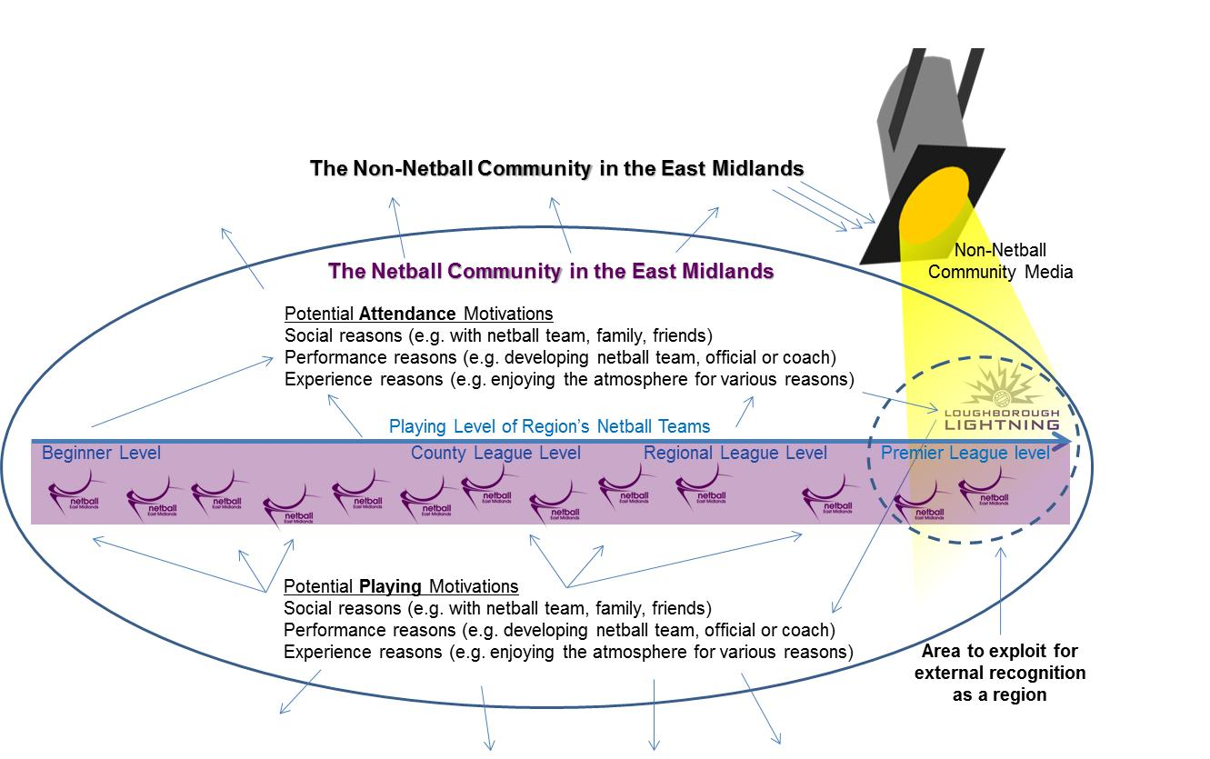
Figure 2: The netball continuum: how Loughborough Lightning is crucial to our success

Importantly though this has opened doors for East Midlands Netball to promote the other side of netball across the region. For example, the group gave BBC Radio Leicester a brief interview in early May and we were also given a 30-minute time slot later on in the month to talk about many aspects of netball, including Loughborough Lightning; netball pathways; volunteering in netball and the regional celebration event. These opportunities only came about because of the collaboration between Loughborough Lightning and the region, which is evident by the fact both the region and Lightning gave interviews together. The groups aim over the next 12 months is to further exploit the relationship with Loughborough Lightning for the benefit of all and importantly to increase media focus on the sport as a whole. The sport is not quite ‘there yet’ for television to constantly keep a track on netball but clearly radio is starting to listen.

To continue the progress of this year, the group will soon be speaking to clubs playing at regional level and indirectly to clubs playing under the county structure by speaking to the county associations. The hope is that small match reports will be written and photographs of games taken by members of each club so that they can be sent to the media to help raise the profile of the sport. However, a key element to this working is for each report to be written within a very short space of time after a match has been played and so the group aims to help clubs form strategies around doing this as well as making introductory contact with a regional club’s local newspapers.

The group has also helped out with the regional Back to Netball Tournament by raising sponsorship money and making a film of the day, which was posted on the East Midlands Netball Facebook page. The hope for the next 12 months is for more events like this to be attended and visual promotions produced.

For the last two months or so, the group has been planning the regional celebration event. We asked what the netball community wanted and for those that responded, we have met your needs. However, having more of the netball community engaged in communication with the region would also help the group judge exactly what is wanted – not just from your celebration event but also in general.

In fact, one of the biggest challenges for the group has been communicating with all members within the region and in a timely manner. The next 12 months will mean a lot of changes occurring but we are confident that more people will give their consent to the Recognition and Profile group contacting them and finding out how we can best serve you.

Peter Dickenson
Recognition and Profile TSG Lead

Youth Action Group

The East Midlands Youth Action Group (EMYAG) saw its’ inception during the current season with the intention of demonstrating the potential of young people in the region to make a positive contribution to our sport. The EMYAG is composed of members from across the region who have all been appointed to the group due to their varied backgrounds in netball so as to ensure the ‘voice of the youth’ within the region is represented as fully as possible.

The EMYAG has had several meetings and has devised a plan for its future development and to ensure it maintains its purpose of action within the region. The group are currently in the process of being aligned within the East Midlands regional structure and are to move forward on confirmation of their standing, working with other TSGs on various projects.

During the current season the EMYAG have contributed to the successful delivery of two events, namely the County Academy Games and the Regional Back to Netball Tournament. The County Academy Games enabled the region’s talented county players to experience competitive and fast-paced match-play, something which supplements the training they are undertaking in their County Academies as part of the Excel Programme. There were three tournaments and each enabled the seven County Academies to field a variety of teams and to face different opposition and the tournaments were succeeded by a Showcase Tournament which saw the County Academies descend on the Netball Centre at Loughborough University to watch the Regional Academy and NTL team play before a Loughborough Lightning Superleague game, enabling players to see for themselves the development pathway open to them from County up to Superleague level.

The Back to Netball (B2N) Tournament saw teams come together that had been involved in the B2N programmes around the region and gave them the opportunity to play in a fun tournament against fellow B2N teams. The tournament was a success similar to the previous year and again took place at Loughborough University.

The EMYAG have been promoting initiatives such as England Netball’s Pass on your Passion programme, aiming to make the region the highest ranking region in terms of members signed up to the programme.

The EMYAG are keen to prove their worth within the region and engage with other TSGs to provide assistance on projects in line with their development plan.

The season has been a success for the EMYAG and their future looks positive if the current year’s progress is anything to go by! Thank you to all those who have contributed positively to the groups’ development and all those who have supported the events mentioned above. A special ‘thank you’ must go to Liz Broomhead, who formed the EMYAG and to Katie Broderick, Regional Coordinator who acted on the group during its initial stages and supported its members in achieving their aspirations!

The group look forward to the next season and the challenges and successes it will bring!

Oliver Hooper
EMYAG Lead

