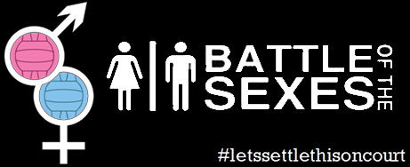

I just wanted to pass on some news from our **Guys V Girls Charity Netball Tournament** which myself Clare Kitchen, and 4 team mates held on Sunday 18th May to raise funds for our Ben Nevis Midnight Challenge which we are doing later this year in aid of the **Alzheimer’s Society.**

Myself, Ellen McGarel, Laura Akers, Rachel Leech and Kate Atterby are from **Bullettes Netball Club** and playing within the Boston Netball League.

Our idea was to challenge the guys and their perceptions of netball to show them just how tough it can be!  So we held a  Battle of the Sexes competition which resulted in a Girl V Girl final between Hurricanes (Sleaford Barge) and The Sweaty Betties, with Hurricanes reigning supreme 11-6.

The day was hugely successful with 16 teams (8 guys and 8 girls) entering 8 Guys (Thrown Together, Kirton Killerz, Kirton Globetrotters, Nothin' but Net, S.M Kent Bullets, All Starz, Tangerine Machine & The Boobie Grabbers) & 8 Girls (Boston United, Sweaty Betties, The Dollies, NetChix, [Lastminute.net](http://Lastminute.net), The Boston Misfits, Hurricanes, Flinders Birds).

The best guys team ended up being Nothin’ but Net who got through to the semi-finals only to be knocked out by Hurricanes. We managed to raise an amazing **£1,400** for our charity on the day which included back to back games of netball, family fun and luckily, lots of sunshine!!!

The best thing about the day was the great effort put in by the Guys and the competitive spirit that came out in everyone involved, so much so, we have decided to make it an annual event given the positive feedback from the day.  It made umpires, coaches and players alike challenge how they thought about and played the game – I would recommend it to anyone who has their doubts!!!

Clare Kitchen

