CHARITY NETBALL TOURNAMENT
Fun for All the Family!!
All proceeds will be donated to the Special Baby Care Unit at Pilgrim Hospital
Registered Charity: 1058065
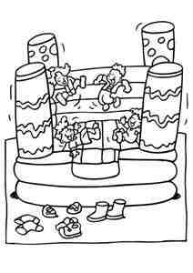
Sunday 8th July 2012
At Boston High School, Spilsby Road, Boston, Lincs PE21 9RS
9.30am for 10am start – 4pm approx
£5 per person to play
Fancy Dress Optional – Baby Themed

Come and join us for a fun-filled day!!
Whether it’s shouting from the sidelines or enjoying an ice-cream in the sunshine,
We’ve something for everyone!!
Bouncy Castle, BBQ & much more!!

Terms & Conditions:
-Teams entered are on a 1st come, 1st served basis. Places are limited
-£10 deposit per team is required by 1st June 2012
-Teams are to provide umpires

For further enquiries or to register, please contact Kim on
kimfletcher85@hotmail.co.uk
Tel : 07715 270633

