Lincolnshire Netball County Association
Finalists in the Lincolnshire Sports Awards 2011
‘Sports Organisation of the Year’

Lincolnshire County Netball Association (LNCA) was nominated Sports Organisation of the Year by Lincolnshire’s Netball Development Officer. They were shortlisted to the final three and attended a glitzy evening and dinner at the Lincolnshire Showground alongside other sporting champions, clubs and organisations from across Lincolnshire.
LCNA was shortlisted for their commitment to the development of netball across the whole of the county, north and south at all levels from grassroots to elite competition; schools; clubs; participants and volunteer recruitment and support.

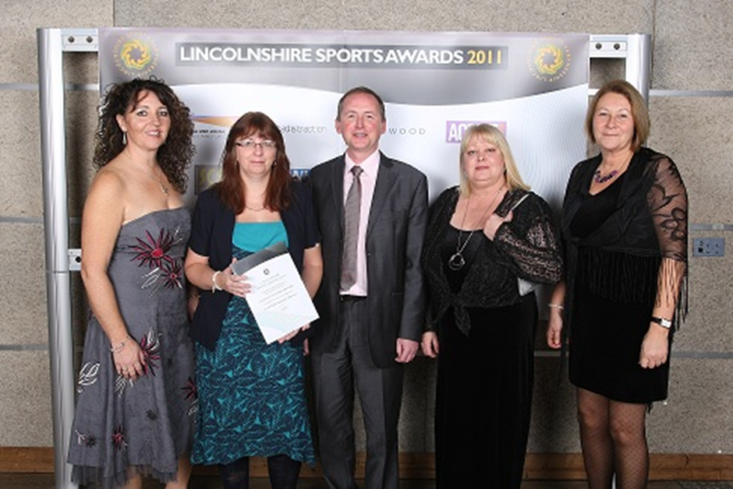
L-R: Louise Key(Netball Development Officer), Vanessa McErlain Naylor (LCNA Chair),
Steve Ince (Blue Castle Energy Ltd, sponsor of the award), Mandy Hall (Talent Scout), Paula Hill (LCNA Secretary)

What was in the nomination?

Competition
• Working in partnership with the Netball Development Officer, schools, and other partner organisations to develop the participant centred approach and competition pathway.
• Clubs support local school competitions through umpiring as part of their school club link agreements.
• LCNA and partners organise and umpire county and regional school finals.
• LCNA provide the umpires/officials for the pilot of the School Games.
• With the loss of county squads, LCNA created a county clubs league with leagues for H5, U12s, 14s, 16s, 19,s and seniors.
• Representation at regional and national competitions
• Lincolnshire has the highest number of affiliated members in clubs and teams in the East Midlands for both juniors and seniors.
• LCNA support the England Netball Back to Netball schemes across the county with bursaries and mentoring for coaches, and equipment for the schemes, creating a competition pathway for the schemes to move into.

Volunteering
• LCNA heavily subsidise NGB officiating courses for their members.
• Offer bursaries (amounts dependant on the coach’s involvement/commitment)
• Offer mentoring opportunities in the county academies.
• Recognise volunteers/officials with their own new sports awards for 2011
• Support the delivery of NGB awards for sports leaders within schools offering opportunities in the clubs.
• Supporting local community events.
• Support of local Young Volunteers to go to Zimbabwe

Recognition/Profile
• North and south county academies to capture all potential athletes.
• Athletes selected for regional and national academies
• Scouts attending local competitions
• CPD workshops for teachers
• Development of county website and resources for clubs and schools.
• All teams within the county league receive awards at the presentation evening
• Nominated to regional and national events
• Lincolnshire achievements constantly recognised in regional and national newsletters and magazines

Inclusion
• LCNA in the early stages of developing a disability club within the county supporting the development of coaches and taster sessions. At present there is only one disability club in the East Midlands

