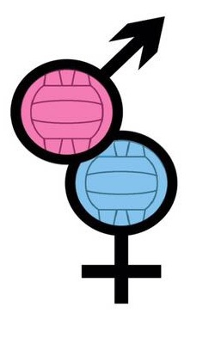
GUYS V GIRLS
Charity Netball Tournament
Sunday June 25th 2017 9:30am – 4pm
Kirton Middlecott Sports Centre
Thomas Middlecott Academy, Edinburgh Drive, Kirton, PE20 1JS
Closing Date for Entries: 9th June 2017
Entry Forms
Please send to GuysVGirls@outlook.com along with a non refundable deposit of £20 per team* or full payment
Entry Fees
£35 per team (7 Players)
£5 per additional player
*Deposit amount will be deducted from your total team payment
All payments
Can be made at one of the two JustGiving links below, You choose which Charity you wish to donate to!
https://www.justgiving.com/fundraising/GuysVGirls2017-Boobs
https://www.justgiving.com/fundraising/GuysvGirls2017-Balls
Umpires
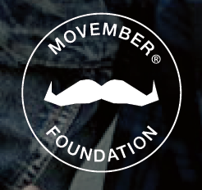
All teams are required to provide a competent and confident umpire who will umpire between their own matches. Additional umpires are available on request at a cost of £30
Any queries please contact the Team at: GuysVGirlsNetball@outlook.com
We look forward to seeing you on court :0)
https://www.facebook.com/groups/GuysVGirlsCharityNetball/
TEAM ENTRY FORM – Guys V Girls 2017
Team Name: _____________________________________________________________
Team Captain: ___________________________________________________________
Tel No: __________________________ Email: __________________________________
2nd Contact (please inc. telephone): ________________________________________
__________________________________________________________________________
Umpire Required? Yes / No (If yes, please pay additional £30)
Name & Grade of Team Umpire/s: _______________________________________ __________________________________________________________________________
No. of Additional Players: (£5 per player)_________________________________

I agree on behalf of my team that all players will:
- Abide by the rules of the England Netball Association and the Guys V Girls Charity Netball Tournament.
- Abide by the umpires decision at all times.
- Allow photographs to be taken during the day that may be used for marketing purposes including on social media
- Be aware that no responsibility will be accepted by the organisers, the charities involved or Kirton Middlecott Sports Centre for injury or loss of property.
- Remove all jewellery and have finger nails cut short
Signed: (please sign or type here)__________________________________________

For queries please contact GuysVGirls@outlook.com

