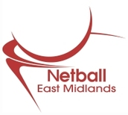 | EAST MIDLANDS NETBALL, APRIL 2015 E-BLAST  East Midlands Netball have decided to do a news blast on a monthly basis so you get a snap shot of what’s happening in the region, up and coming events and hopefully you won’t miss out on anything. This can then be sent on to anyone you feel might like to see it.  If you decide you no longer wish to receive this information, just drop us an email and we will remove you from our list.
2015 Goalden Globe Awards & AGM Notice

Sunday 21st June 2015, Radisson Blu, East Midlands Airport

Closing date for nominations, Friday 1st May! Click here for all categories and nomination forms.

The event is open to all; tickets are only £20 per person for a 2 course meal and complimentary wine/soft drinks. Come and join us – bring your team along. There will be raffles with fantastic prizes, goodie bags, and lots of fun fundraising for Cancer Research UK!

Bar Lane Community Sports, Nottingham- New League!

Bar Lane are offering Netballers the opportunity to play friendly Nets matches at their venue on Wednesday and Thursday evenings ahead of their Mixed Tournament on Thursday 7th May, and launch of their Summer League on Thursday 4th June.
Further information and registration forms for the tournament and league can be found on our website.

The Centre is also on the lookout for Umpires… Umpires will be paid £6.50 per match (40 minutes). For further details contact Bob Manca directly on: 0115 9244766; info@barlanecommunitysports.co.uk.

Willows Sports Centre, Derby- Summer Netball!

Would you like to play more netball this summer? If you love your netball and wish that it went on all-year-round, you can continue to play Netball in friendly and competitive leagues at Willows Sports Centre in Derby.

There are currently team vacancies on Thursday evenings (traditional 7 aside Netball) and Tuesday evenings (6 aside Nets). If you aren’t sure that Nets is for you, the Centre are hosting two open evenings on 5th & 12th May- from 6pm both evenings, ladies and mixed, £22.20 per team.

For further details, please contact the Centre directly:
info@willowssportscentre.co.uk; 01332 204004.

Big Summer of Netball Grants Scheme

Following the success of last year’s campaign, the Big Summer of Netball Grants Scheme is back!
Grants of up to £1000 are available to netball organisations (non-commercial) such as clubs, leagues, counties, regions, universities and County Sport Partnerships who can set-up new netball opportunities this summer .

Application forms can be found on our website and must be submitted to BigSummerofNetball@englandnetball.co.uk by Friday 15th May for consideration.

Fast Net Tournament- Booking now live!

On Saturday 4th July 2015, the Regional Volunteer and Club Development TSG (Technical Support Group) will be running a Charity Fast Net Tournament at Soar Valley Netball Centre. All funds raised will go to Cancer Research UK. Entry forms are now on our website.

Junior Netball Tournaments

There are a number of Junior Tournaments planned throughout Spring. Take a look at the Regional Website’s events page to see full details on the upcoming Junior Tournaments. There are events coming up on: 16th May & 6th June!

Umpiring & Coaching Courses

- C Award Umpiring Course- 16th May- Deans Sport and Leisure, Lincoln
Contact Robyn Rogers for more details rrogers@chesapeake.co.uk; 07773 484717 or go to our website.
- New UKCC Courses to be announced early June

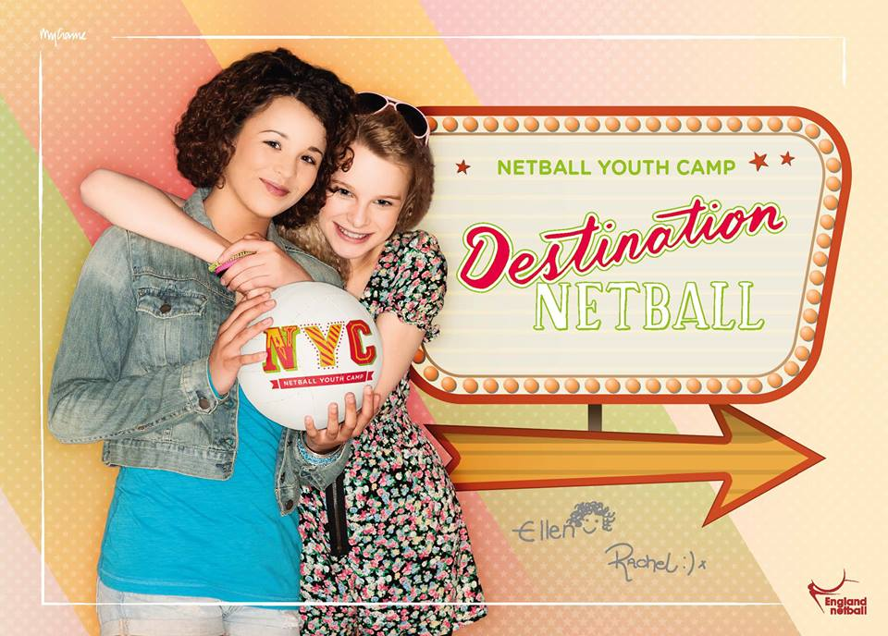 | Netball Youth Camps  Netball Youth Camps are back for Summer 2015 with two running in the East Midlands for Netballers aged 11-16…  NYC Nottingham/Derby  3 Day Camp- Wednesday 29th to Friday 31st July- Trent College, Derbyshire  NYC Moulton  1 Day Camp- Thursday 6th August- Moulton School, Northamptonshire  To book, or for more information, visit- www.netballevents.co.uk
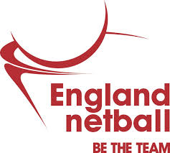 | England Netball Volunteer Vacancies  Chairman- At the forefront of Women’s sport, England Netball is looking for a proven leader to take it into a new era. The Chair will focus on the strategy and vision working with the leadership team and be a “champion” of the values, vision and mission of the sport.  President- England Netball is looking for an inspirational figurehead for the sport, raising the profile of the sport and celebrating and promoting those involved in the game in particular the members and volunteers.  Do you have what England Netball are looking for – full details and application forms are on the England Netball website.
County & Regional Vacancies

With the East Midlands Netball AGM around the corner (Sunday 21st June), the Regional Management Board are looking to recruit a new Vice Chairperson, and Elected Member.

Full role descriptions, alongside application forms can be found on our Regional Website.

All nominations; applications; resolutions; proposals and attendance replies should reach the regional office no later than mid-day on Friday 22nd May 2015.

Regional Newsletter

We are always on the lookout for good news stories throughout the East Midlands to share in our Regional Newsletter. If you would like to feature in our next issue, please send us your story! A useful template is available on our website and can be downloaded by clicking here.

The cut-off date for July’s newsletter is Friday 24th July.

Staff Updates

Please note that Stephanie Orr (East Midlands Regional Coordinator) will be on Annual Leave on the following dates Monday 27th April – Friday 1st May (inclusive).

Should you have any urgent queries during this time, please contact either England Netball Head Office, or the relevant contact below:

East Midlands Regional Manager- Melissa Carr
melissa.carr@englandnetball.co.uk / 07970 059904

Derbyshire/Nottinghamshire Netball Development Officer – Julian Taylor
julian.taylor@englandnetball.co.uk / 07545 924993

Nottinghamshire/Derbyshire Netball Development Community Coach- Ruth Pickthorn ruth.pickthorn@englandnetball.co.uk / 07872 407215
Lincolnshire Netball Development Officer – Louise Key
louise.key@englandnetball.co.uk / 07545 924994
Leicestershire Netball Development Officer – Val Kindred
v.kindred@lrsport.org / 07540 126816
Northamptonshire Netball Development Officer – Kelly Walker
kelly.walker@englandnetball.co.uk / 07545 924954

East Midland Performance Pathway Coach- Sam Brightman
samantha.brightman@englandnetball.co.uk / 07525 702639

To keep updated with everything that is going on in the Region, don’t forget to check out our website and follow us on social media-
www.eastmidlandsnetball.co.uk/

www.facebook.com/EastMidlandsNetball
@EastMidlandsNet

