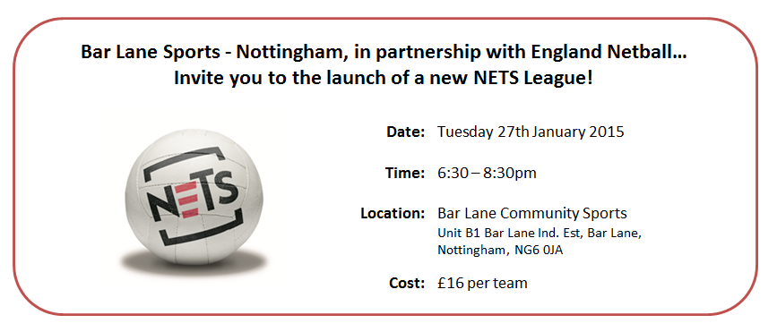
Please complete (where applicable) and to either of the following by Wednesday 21st January 2015:
East Midlands Netball, Netball Office, Loughborough University, Leicestershire, LE11 3TU
eastmidlands@englandnetball.co.uk
The payment of £16 can be returned with the booking form (cash, or cheque made payable to: ‘Bar Lane Community Sports’), or can be paid on the evening of the launch.

Club Details
Name | County | EN Affiliation Number (if applicable)

Contact Details (one person- to be contacted in case of event alterations)
Name | Contact Number | Contact Email

Payment Option (please select)
Please find enclosed a cheque for £16/ check to be posted to Regional Office
Please find enclosed £16 cash/cash to be posted to the Regional Office
£16 to be paid on evening of event

Attendees
 | Name | Role on the day (please highlight)
1 |  | Player / Umpire / Coach / Observer
2 |  | Player / Umpire / Coach / Observer
3 |  | Player / Umpire / Coach / Observer
4 |  | Player / Umpire / Coach / Observer
5 |  | Player / Umpire / Coach / Observer
6 |  | Player / Umpire / Coach / Observer
7 |  | Player / Umpire / Coach / Observer
8 |  | Player / Umpire / Coach / Observer
9 |  | Player / Umpire / Coach / Observer
10 |  | Player / Umpire / Coach / Observer

Please let us know if you have had any previous experience of NETS…

Thank You! We look forward to seeing you on Tuesday 27th January!

