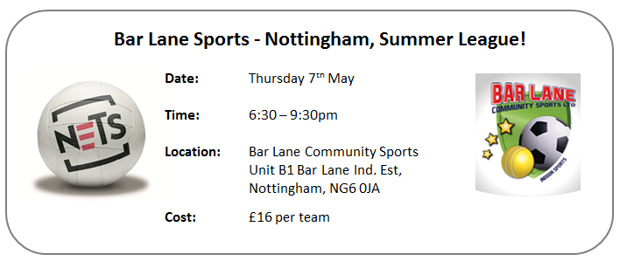
Grab your work mates, teammates or any mates and come and get involved in our Summer Netball League! A series of 7 aside games across two courts; matches will start on Thursday 4th June and run every Thursday throughout the Summer. Please note that you do not need to be an England Netball affiliated player to play in this league; the Centre is a partner of England Netball and does have its own public liability.

The Summer league will be completely run by our large 50” plasma screen computerised score boards that run the time clocks/immediately update the league tables after each game has finished/ensure all matches start & finish on time/and will even register your Team Colours!!! All matches to be umpired by a qualified umpire.
Please complete and return this document to one of the following by Friday 22nd May 2015:
Unit B1, Bar Lane, Bar Lane Industrial Estate, Basford, Nottingham, NG6 0JA
info@barlanecommunitysports.co.uk

The first payment of £16 can be returned with the booking form (cash, or cheque made payable to: ‘Bar Lane Community Sports’), or can be paid on the evening of the league.

Team Info Required
Team Name
Team Colours

Team Captain Contact Details Required
Name
Address
Home Phone
Mobile Phone
Email

Vice-Captain Contact Details Required
Name
Address
Home Phone
Mobile Phone
Email

Payment Option (please select)
Please find enclosed a cheque for £16 (cheque to be posted to Bar Lane with form)
Please find enclosed £16 cash (cash to be posted to Bar Lane with form)
£16 to be paid on evening of event

Thank You for entering. We shall contact you ahead of the league with further details on fixtures.

