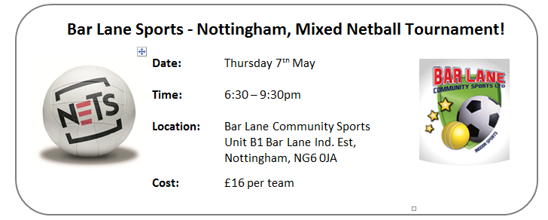
Grab your work mates, teammates or any mates and come and get involved in our Mixed Netball Tournament! A series of 7 aside games across two courts; maximum of three males on court at all times.

The Tournament will be completely run by our large 50” plasma screen computerised score boards that run the time clocks/immediately update the league tables after each game has finished/ensure all matches start & finish on time/and will even register your Team Colours!!!

All matches to be umpired by a qualified umpire.

Please complete and return this form to one of the following by Monday 4th May 2015:
Unit B1, Bar Lane, Bar Lane Industrial Estate, Basford, Nottingham, NG6 0JA
info@barlanecommunitysports.co.uk

The payment of £16 can be returned with the booking form (cash, or cheque made payable to: ‘Bar Lane Community Sports’), or can be paid on the evening of the tournament.

Please note that you do not need to be an England Netball affiliated player to play in this tournament; the Centre is a partner of England Netball and does have its own public liability.

Team Info Required
Team Name
Team Colours

Contact Details Required
Name
Address
Postcode
Home Phone
Mobile Phone
Email

Payment Option (please select)
Please find enclosed a cheque for £16 (cheque to be posted to Bar Lane with form)
Please find enclosed £16 cash (cash to be posted to Bar Lane with form)
£16 to be paid on evening of event

Thank You for entering. We shall contact you ahead of the event with further details.

