Officiating Assessor CPD Award

This course reinforces the principals of assessment in the world of netball officiating. It is ideal for active officiating assessors to help to develop the next generation of netball umpires.
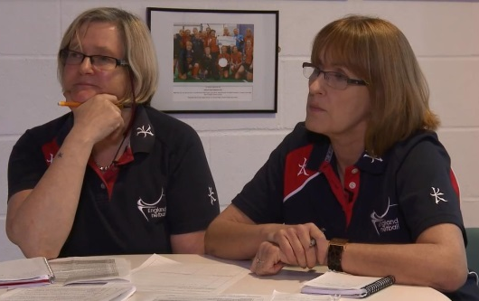

The Officiating Assessor CPD Award is open to existing accredited (2012) England Netball Officiating Award Assessors who hold a valid Netball Europe Umpire Award and requires attendance at a one day course led by an England Netball appointed Tutor.

Key Course Objectives
- Introduce the principles of the seven stages of assessment
- Reinforce best practices in the technical aspects of an assessment within the officiating environment
- Understanding of the role that the assessor plays in netball and sport as a whole

Who Can Become An Officiating Assessor?
In order to become an accredited Officiating Assessor you must:
- Hold a valid Netball Europe B Umpire Award Qualification or above
- Be a minimum of 18 years of age at the date of the course
- Be an affiliated or Honorary member of England Netball

How can I Gain the Officiating Assessor Award?
The trainee must attend the full one day course where they will receive the relevant information and an Assessor Learner Resource.
Officiating Assessor Courses are organised by England Netball. The cost of attending the one day course is £90, however existing Assessors will receive a 50% discount. To find an upcoming course in your area, please visit:
http://www.englandnetball.co.uk/make-the-game/officiating/Assessor_Training
For more information please visit www.englandnetball.co.uk/make-the-game/officiating

